CIS/STA 9660 Final Project

Professor: Lawrence Tatum

Abstract

SVM methods classify the observations by separating the   
observation space into different part using a hyperplane

SVm: Art of separation

Yang Jin

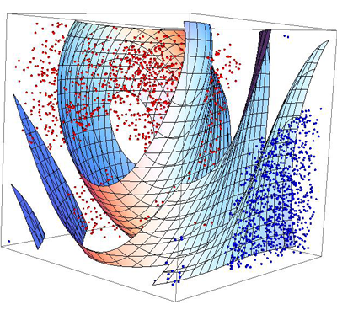**[1]**

Table of Contents Page

Support Vector Machines 3

1.1 Introduction 3

1.2 Maximal Margin Classifier 3

1.3 Support Vector Classifiers 4

1.4 Support Vector Machines 6

1.5 Walk through SVM in R 7

Apply SVM to Stock Daily Range Data 10

2.1 Introduction to the data set 10

2.2 Cleanse of the data set 10

2.3 Apply SVM on cleaned stock range data set 11

2.4 Apply non-linear SVM 13

2.5 Apply SVM to reduced dimensional range data 15

Apply SVM to Original Data Set 17

3.1 Introduction to the data set 17

3.2 Cleanse of the data set 18

3.3 Apply SVM on cleaned property data 19

3.4 Apply non-linear SVM 21

Reference List 23

# **Support Vector Machines**

## **1.1 Introduction**

The support vector machine is one of classification methods. In general, this method finds a hyperplane to separate the dataset into different categories. It is a generalization and improvement on of a classifier method called the *maximal margin classifier.*

Description Above is not enough to get sense of SVM. Only thing need to know is it use a hyperplane to separate the dataset and then classify. What is a hyperplane? In a p-dimensional space, a hyperplane is a flat affine subspace of dimension p – 1[2].

To be clear, imaging there is a 3-dimensional space, for example, a cube, then according to the definition, a hyperplane is a 2-dimensional space, which is a surface. Again, for a 2-dimensional space, its hyperplane is a one-dimensional space, which is just a line.

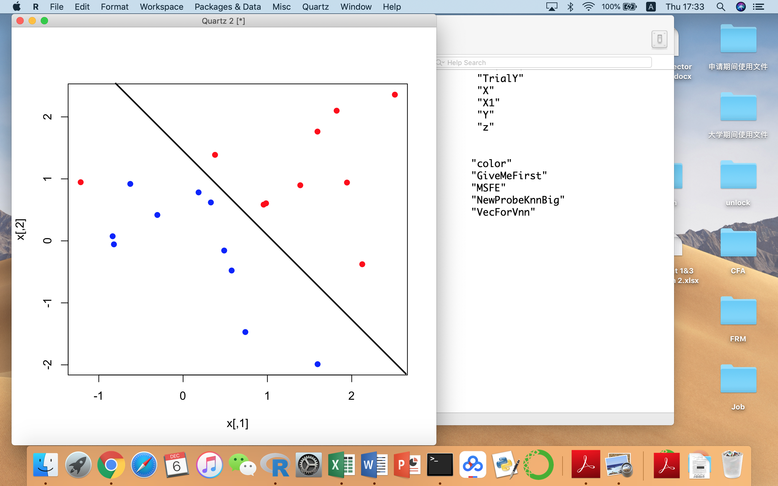Under a 2-dimensional space, it will be more intuitive. Recall SVM is trying to find a hyperplane to separate the dataset, and then classify them. A hyperplane in a 2-dimensional space is a line.

What does this mean? SVM is trying to find a line to separate the space, and assign categories to different parts.

Imaging the dataset has two different colors of dots, blue and red, plotted on a coordinate system. What SVM does in this plot? It finds a line to cut the whole coordinate into half so that on one side of it is red and the other is blue. This is what “separate” and “classify” implemented in SVM method under a 2-dimensional space.

For higher dimensional spaces, SVM then tries to find a high dimensional “line” to cut the space into pieces and ensure each piece contains the majority of data points belonging to the same category.

## **1.2 Maximal Margin Classifier**

After having a general idea about how the SVM classify the data points (find a line cut the space into half and assign different categories to each part), it is time to talk about how SVM find a hyperplane (line).

The most basic idea is using *maximal margin hyperplane*. As its name indicates, maximal margin hyperplane method finds the hyperplane which has the maximal margin. So what is the margin defined here? That is, first computing the perpendicular distance from each data point to a given separating hyperplane; the smallest such distance is the minimal distance from the point to the hyperplane, and is known as the margin. The maximal margin hyperplane is the separating hyperplane for which the margin is largest—that is, it is the hyperplane that has the biggest minimum distance to the training observations. We can then classify a test observation based on which side of the maximal margin hyperplane it lies[3].

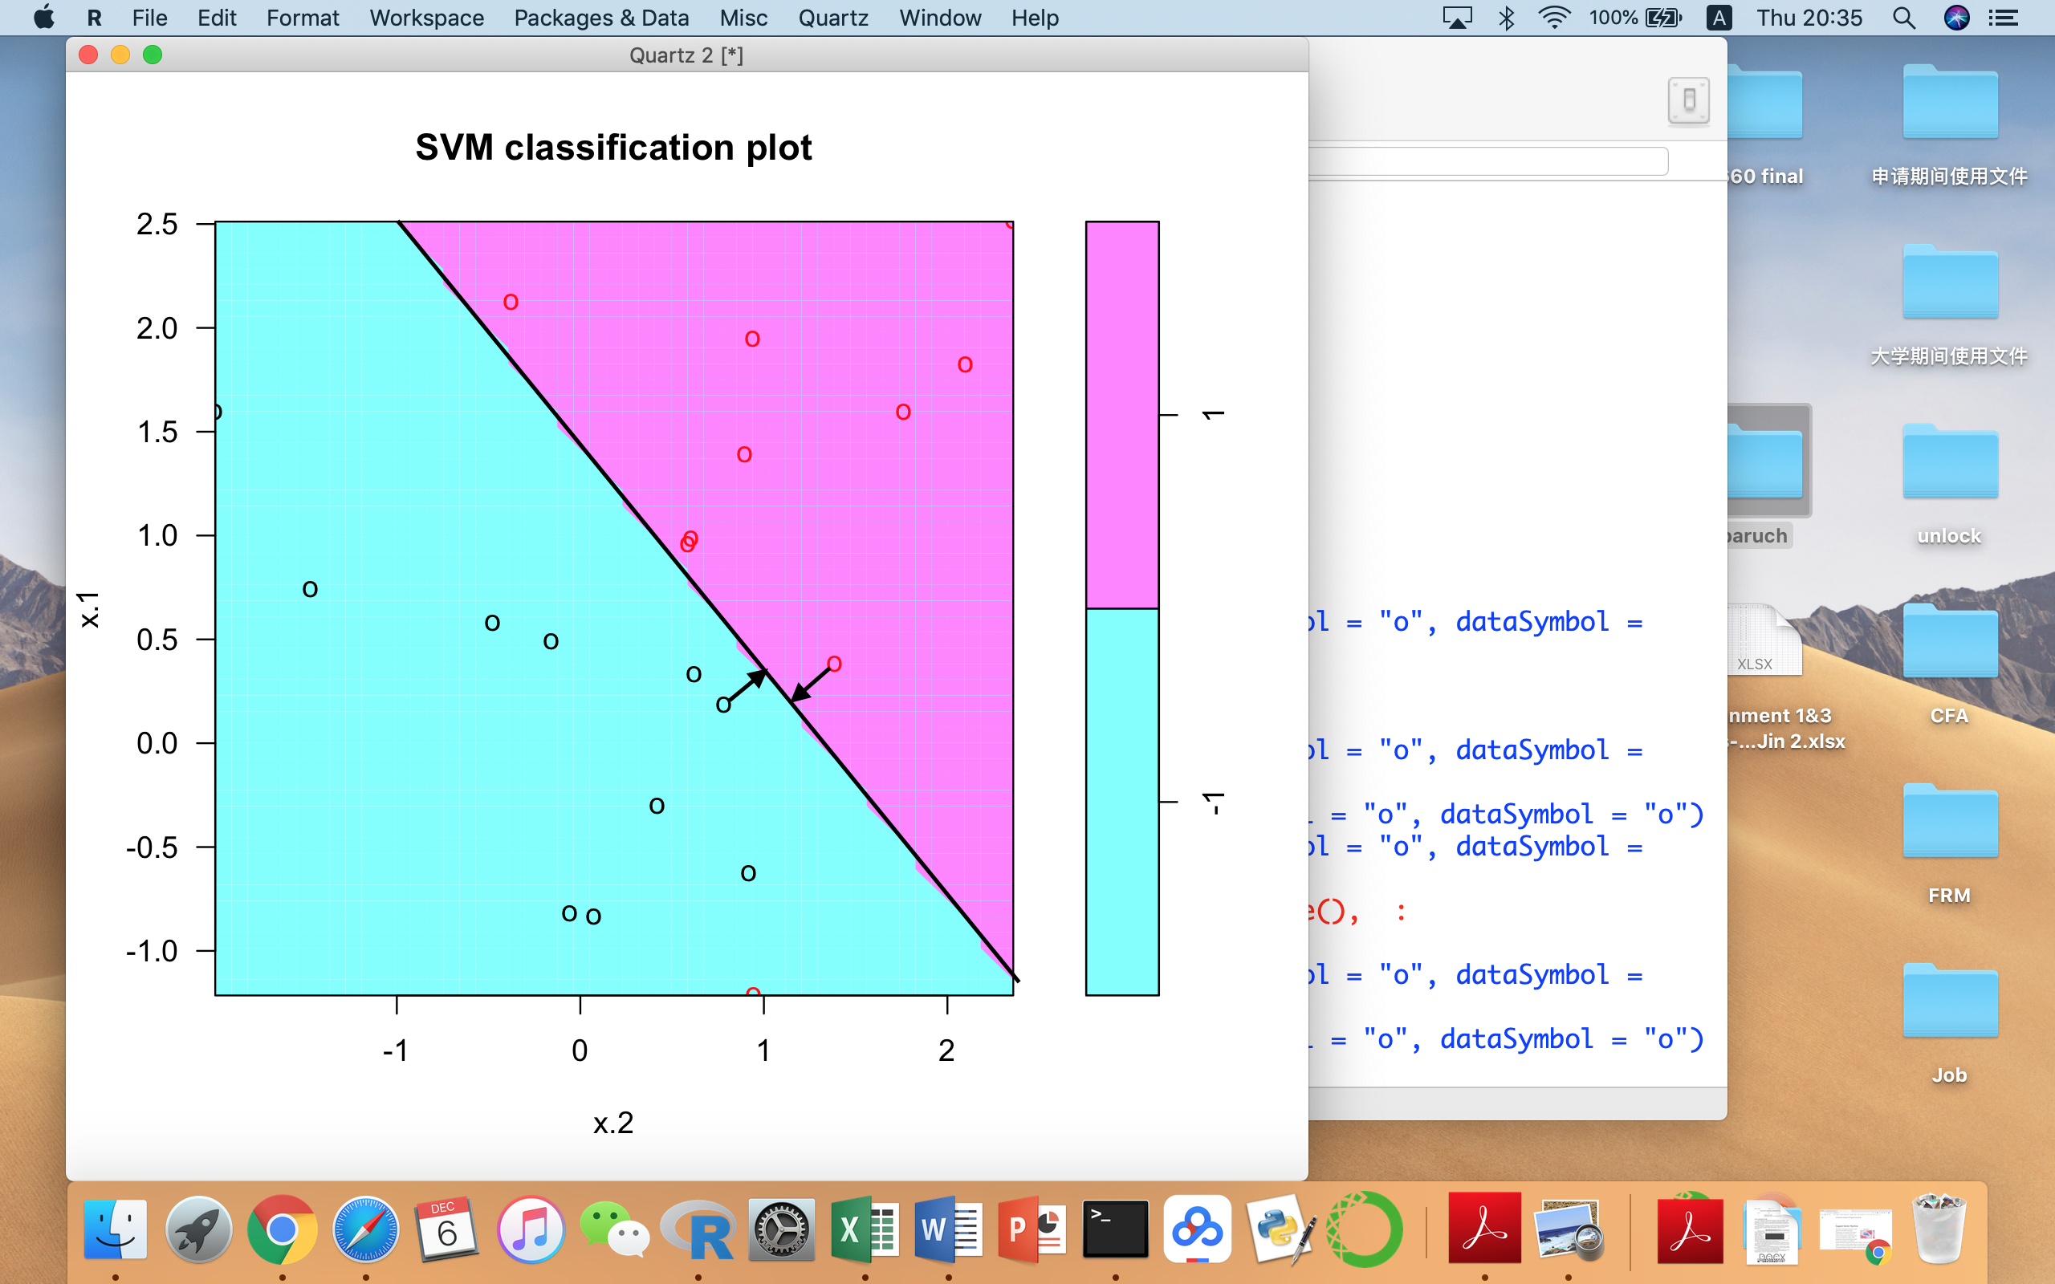To make easier, imaging a 2-deminsional space, the *maximal margin hyperplane* finds a line maximizes the distances from all data points to the line. And the distances from all data points to the line (*solid line*) is defined as the minimal perpendicular distance (*arrows*) from each data point to the line.

In some way, the minimal distance of all the data points to the line is used in this method, which also means only few points have the influence on the determination of the line!

## **1.3 Support Vector Classifiers**

However, there is one simple issue in Maximal Margin classification method. It makes a hidden assumption; the data set is separable. This is usually not true for many data.

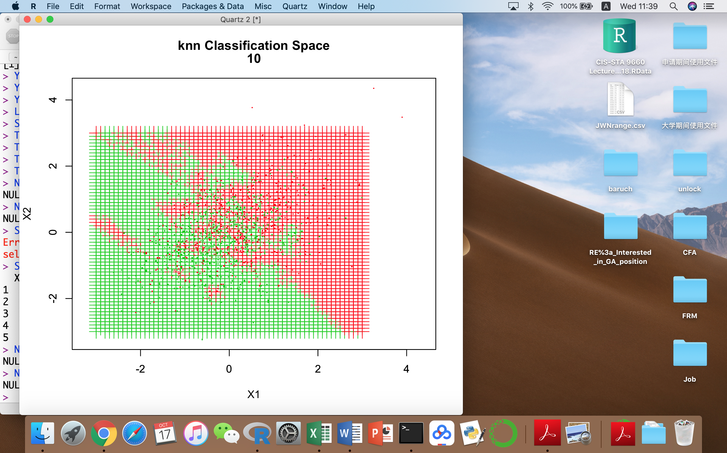For example, I put my daily range k-NN classification plot here. Obviously, there are many green points in the red area, and red points inside green areas. If a Maximal Margin Classifier method is used in this data set, it might not give a hyperplane as expected. When a non-separable data set exists, an optimized hyperplane is not desirable. Alternatively, *Support Vector Classifiers* gives some allowance for incorrect classifications, which can be determined by the user.

The support vector classifier, is a simple improvement of *Maximal Margin Classifier*, which allows wrong classification. Rather than only aiming at find the best solution, it tries to find a hyperplane and its margin that more data points are both on the correct side of the hyperplane and also on the correct side of the margin[4].

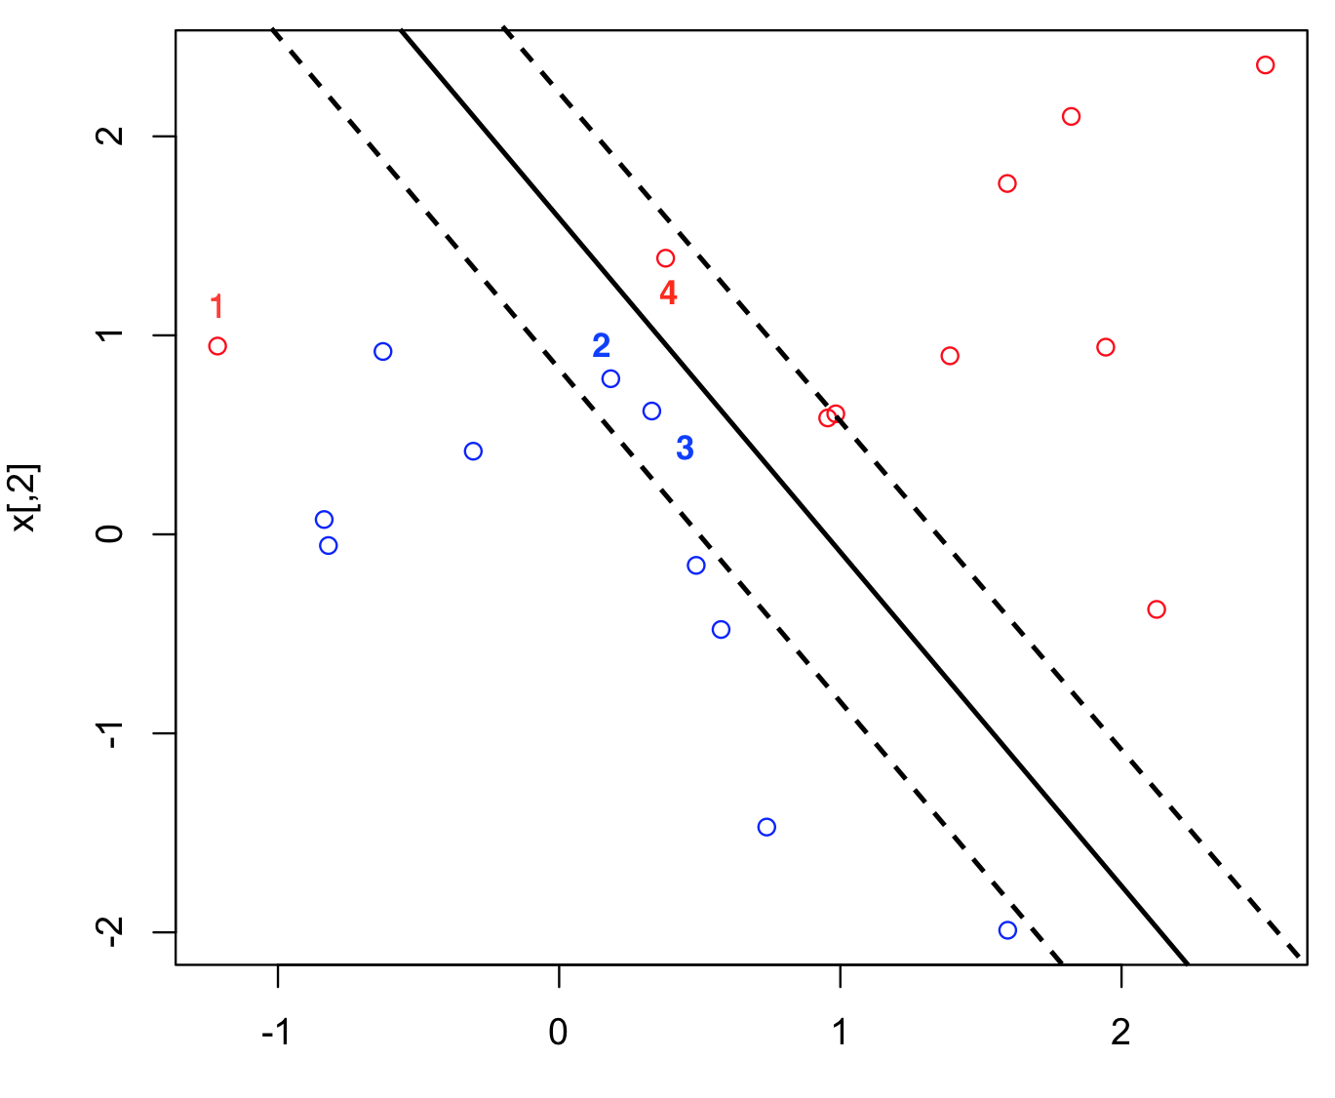

Looking at this graph. Point 1 is on the left of the hyperplane (solid line), and also on the left side of the margin (dot line), so this point is called on the wrong side of hyperplane and margin. For points 2 and 3, they are on the right side (wrong side) of the margin, but on the left side of the hyperplane (right side). Point 4 is also on the right of the hyperplane but on the wrong side of the margin.

Recall the margin is the minimal distance to the hyperplane, which is two parallel hyperplane(lines) on the both sides of the hyperplane (the separating line in 2-demantional space). In short, the wrong side of hyperplane means the point was classified wrong. The wrong side of the margin means these points are still classified correctly but too close to the hyperplane, which indicates potential misclassification on these points.

Then, an allowance level is selected for this method. It is called tuning parameter *C* in ISL text[5]. In the SVM in R, it is named as the “cost” for the SVM. I will use the same notation as ISL text.

If *C* = 0 then there is no allowance for violations to the margin, in this case, it is same as the *Maximal Margin Classifier* in the previous part. The method only wants to find the best hyperplane, which performances poorly in non-separable data sets.

In *Support Vector Classifiers, C* > 0, the method will allow *C* points could be misclassified. As the allowance level *C* increases, the method becomes more tolerant to misclassification, and the margin will become widen. Why? Because more points face potential misclassification!

## **1.4 Support Vector Machines**

The *Maximal Margin Classifier* gives the basic idea of finding a hyperplane (a line in 2-deminsional space) to separate the data sets so that each side belongs to different categories. This is the essential idea of SVM method. Then, an improvement is introduced on it, called *Support Vector Classifiers*. This method allows the misclassification inside the data sets, so that it can fit into the real data. However, the methods still need improvement![6]

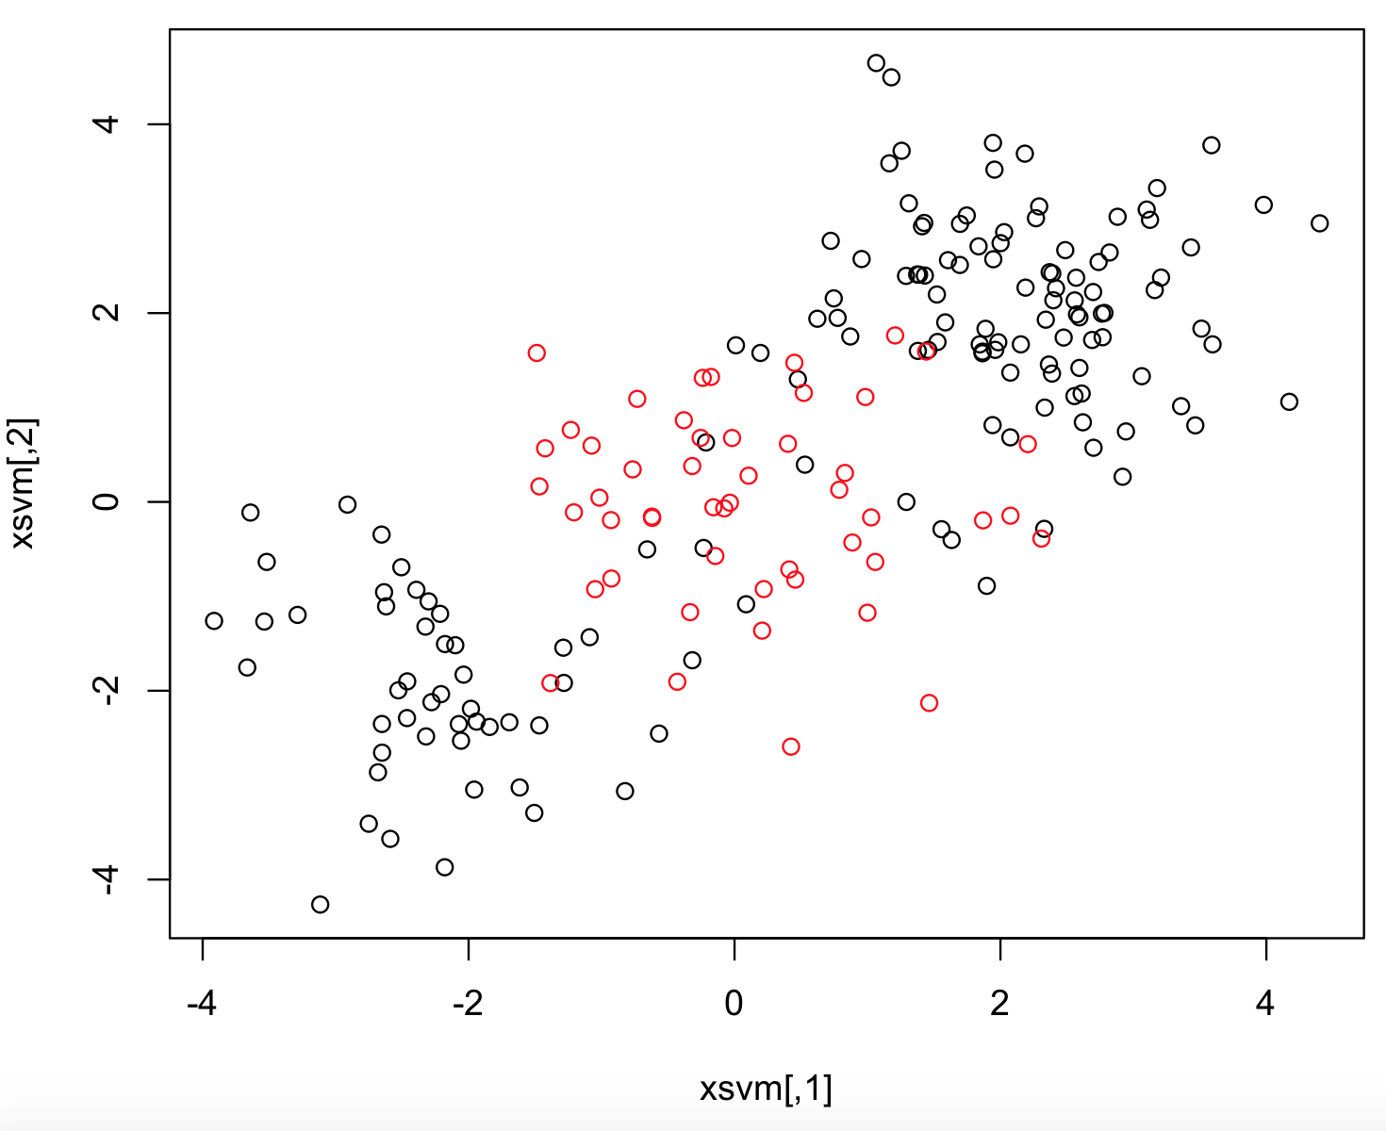

So far, previous two methods use a hyperplane to separate the data sets. In every plot, it is obvious that the hyperplane is a solid straight line. What if many points belonging to one category concentrate in one area? A linear hyperplane will work poorly in this situation. A solid line cannot separate the coordinate correctly. A closed shape, like a circle or a square, might be able to include the red points, so that all the points inside the shape belong to red and points outside are all black.

*Support Vector Machines* is the method improved for solving the non-linear boundary classification. The details about how this method works is beyond the scope and not introduced in the ISL text. I understand this as following. SVM introduce a *kernel* function, which measures the similarity between the points[7]. Recall in the simplest method, *Maximal Margin Classifier*, use the perpendicular distance as the measure of distance. Here, SVM use the kernel function as the replacement of perpendicular distance. Then applying a similar idea as previous methods to find hyperplane to separate the data sets. *Kernel* function can be further replaced by *polynomial kernel*, which allow using curves rather than straight lines to separate the data sets. Instead, *radial kernel* can produce closed shapes to do the classification.

Until now, what I talked are all under a simple assumption: the data sets have only 2 categories, 0 or 1. This assumption doesn’t always hold in real world. The built-in iris flower data set has 3 different flower types inside it. An improvement is called *One-Versus-One Classification*, which take pairs of points into consideration rather than classifying one point at a time. A further improvement is called *One-Versus-All Classification* which take a pair of k points at one time rather than 2 points.

## **1.5 Walk through SVM in R**

First of all, the proper library should be included. For the SVM, it requires e1071 library. Following the ISL text, I first create a test data set filled with random numbers and randomly assigned categories. I will test SVM on it to see how outcomes look like.

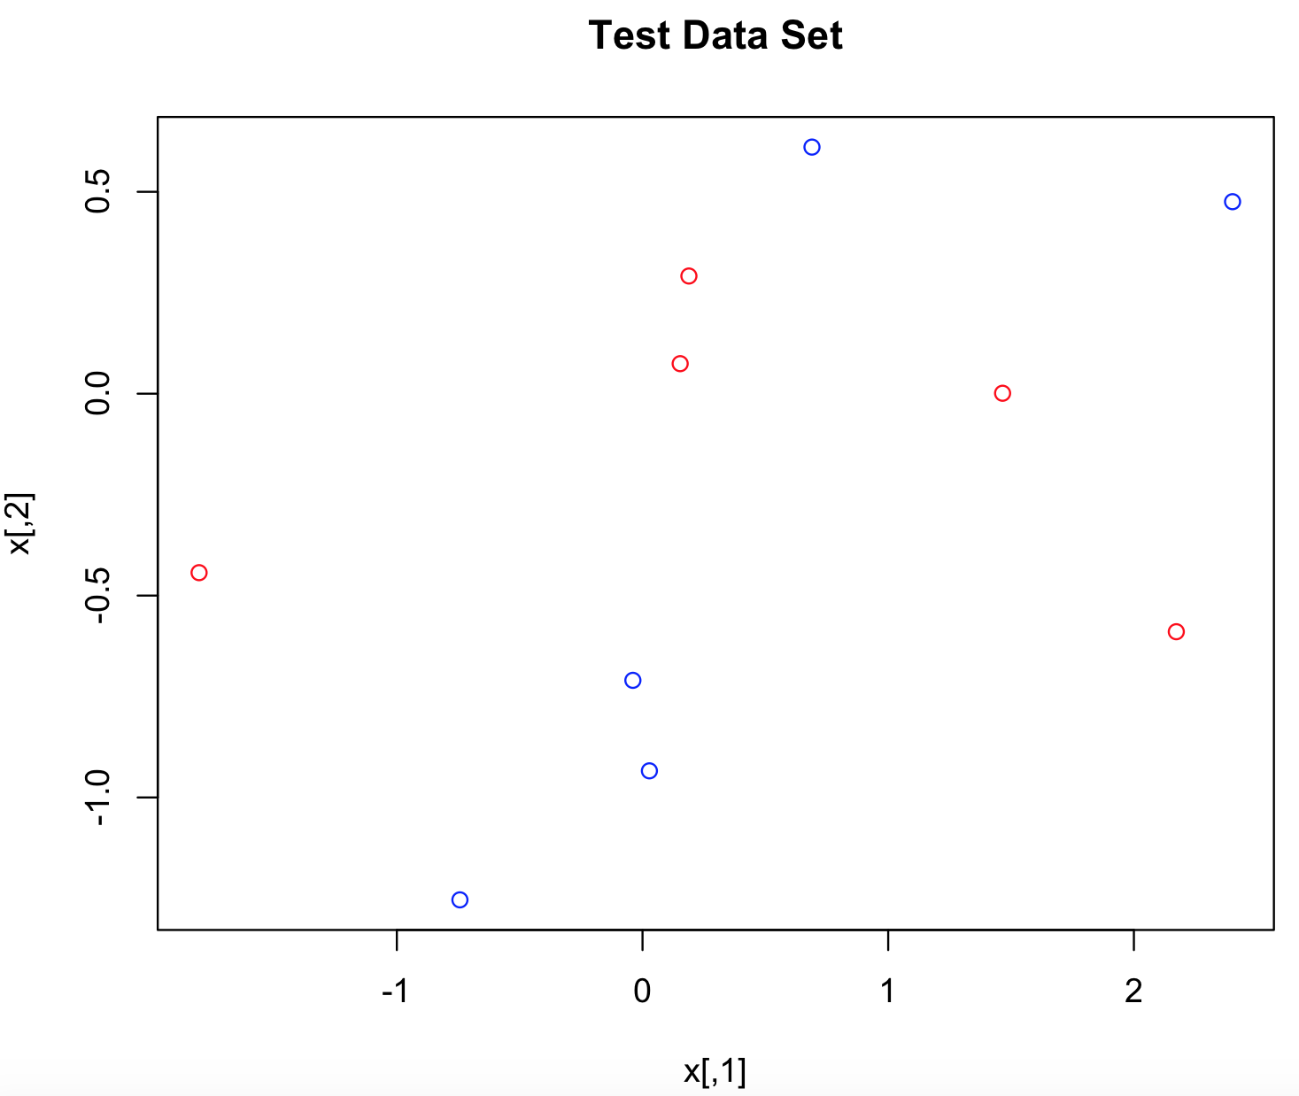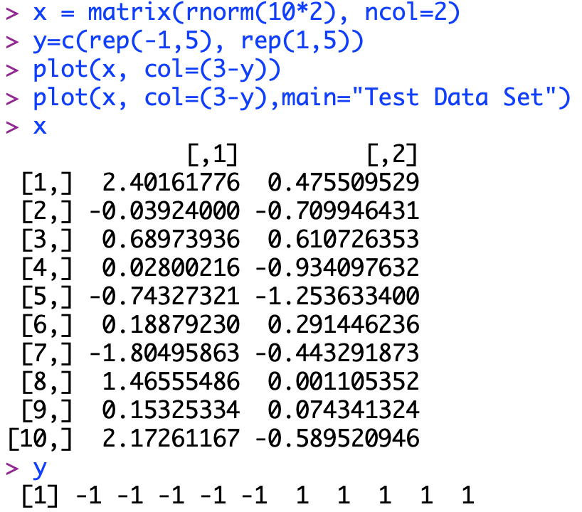I use the following codes to generate a test data set. I first create my x variable with 10 rows and 2 columns, inside which are all random numbers. Then, my y variable is simply assign category “1” to the first five rows and “-1” to the rest of them. I plot them in the “Test Data set graph”.[8] In ISL text, it changed the x variable to get a better classification.

I can see that there are red points on the upside of the plot. The coordinate and category of these points are randomly generated and assigned. They don’t have a special meaning. Then I put everything together as a dataframe and y as the factor, similar to a logistic regression. After importing the e1071 library (seems this library is included originally in R and no need for downloading), I run the SVM method on the data set.

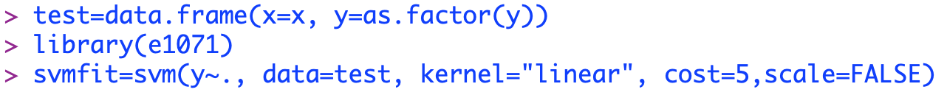

The “y~.” commend simply means do SVM by using “y” as y variable and the rest as x variable. Select the “test” data set as the data set I want to use, and set the kind of SVM I want to use. Recall that there is a linear SVM method called *Support Vector Classifiers* which always produce a linear hyperplane (a straight line) to separate the data set. A larger “cost” indicates more tolerance on wrong classification. Scale means whether to standardize the data set. Using 

to plot the SVM fitting result with the original data set.

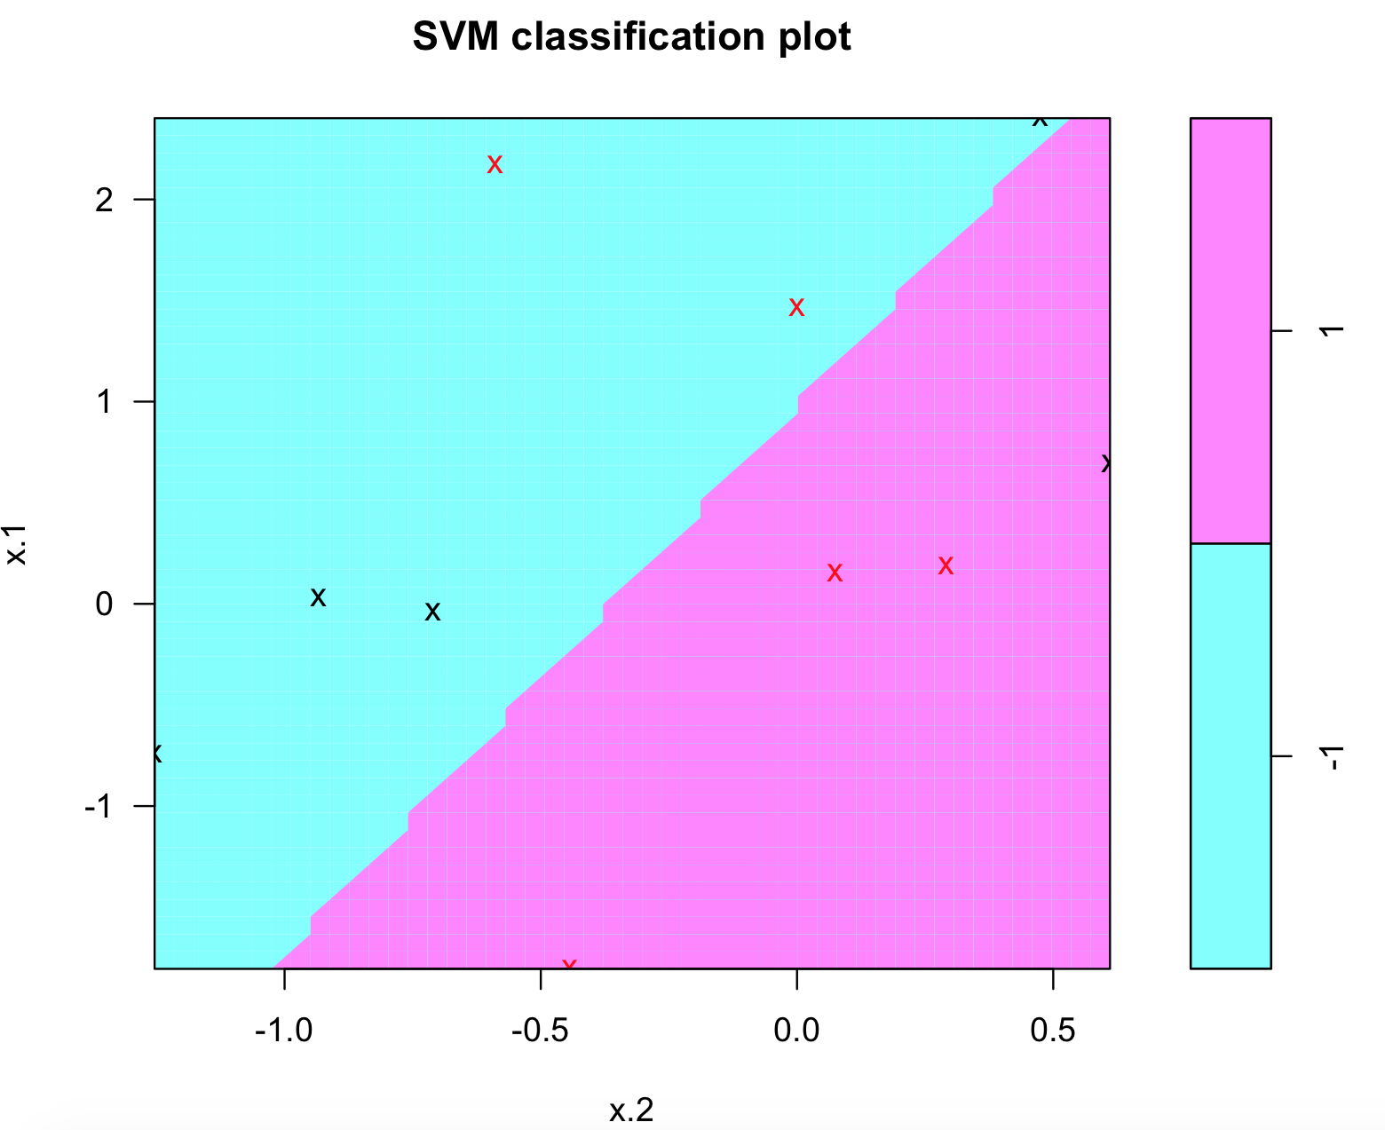

Notice the x and y axis (x.1 & x.2 here) have been turn over comparing to the “Test Data Set” plot before. Also, there isn’t any line or curve on the plot at all! It is not intuitive, but it is good for decision making for new data points. If a point is in purple area, it is more likely belonging to purple category. The points marked as cross means they are the points SVM used to define the hyperplane, called *support vectors*.

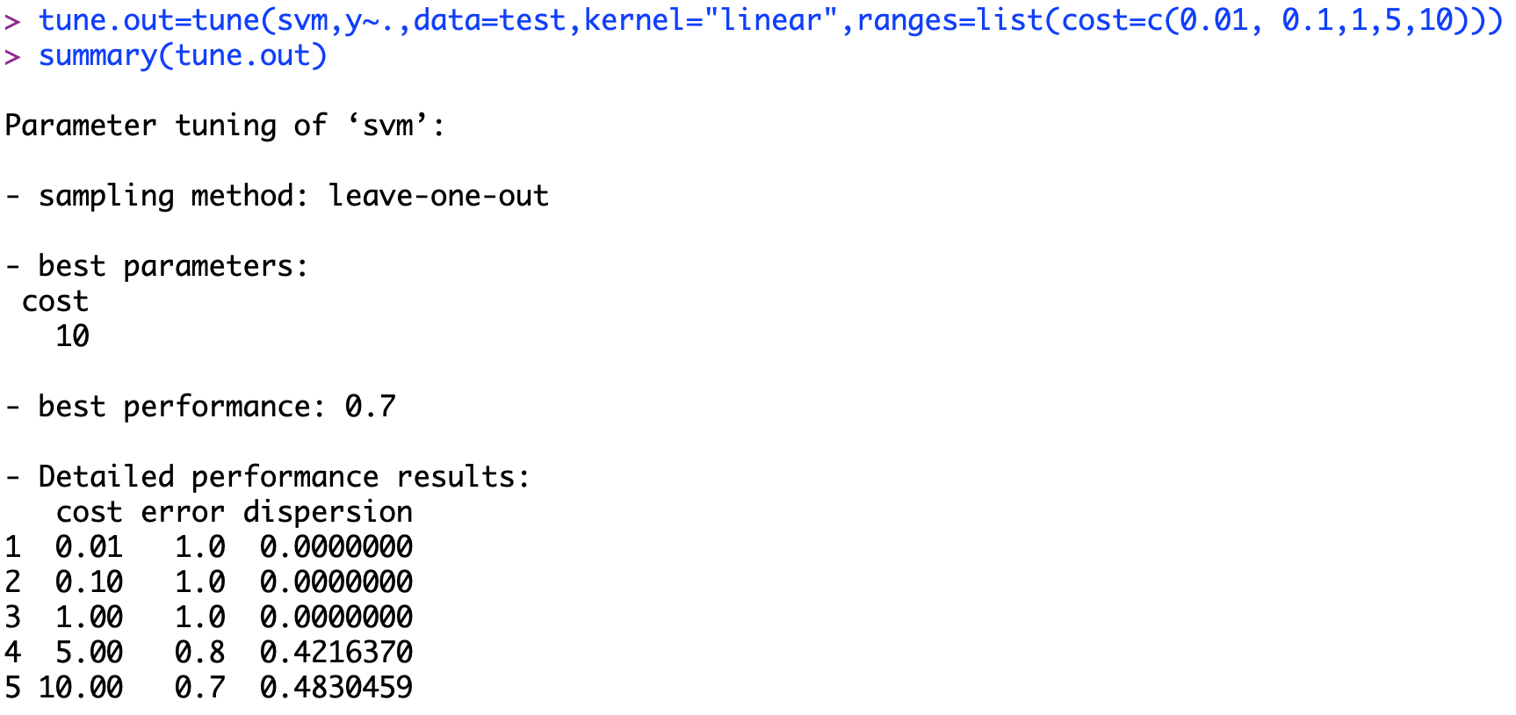Inside e1071 library, there is a “tune” function which can perform cross-validation for the SVM fitting. This function allows input of multiple cost levels and select the best cost level. Recall here, cross validation here is a sub-model selection method that performing SVM on part of the data set as train set and test its fit on the rest.

Here, I test cost level from 0.01 to 10. The result shows that the best cost is 10. Different from a simple thought that the smaller the cost is, the better the classification will be; the cross-validation shows cost level 10 is better than 1. Notice the “sampling method” is “leave-one-out” rather than the “10-fold cross validation” in the ISL text[9]. My test data might be too small for cross validation.

Finally, I used the best model after cross validation to predict the y variable and compare to the original data set, just like what is done for the logistic regression and other classification method.

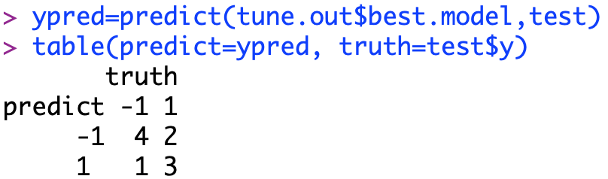

Computing the correct ratio, (4+3)/ (4+2+1+3) = 70%. It is not bad.

In the following part, I will apply the non-linear SVM method on the test data set. To use a radial kernel SVM method, simply change the kernel = “radial”. Also, a “gamma” parameter need to be specified in radial SVM. The detailed meaning of gamma is not discussed in ISL text, [10]but I guess it is some kind of shape controlling parameter to modify the shape of hyperplane to find a better fit.



A cross-validation method could also be used here. I tested several cost level and different gamma level to find a best combination of both.

The graph below looks a bit better than the linear boundary. The purple part now is between two blue parts. The original “Test Data Set” plot has the similar feature that red points are in the middle of blue points.

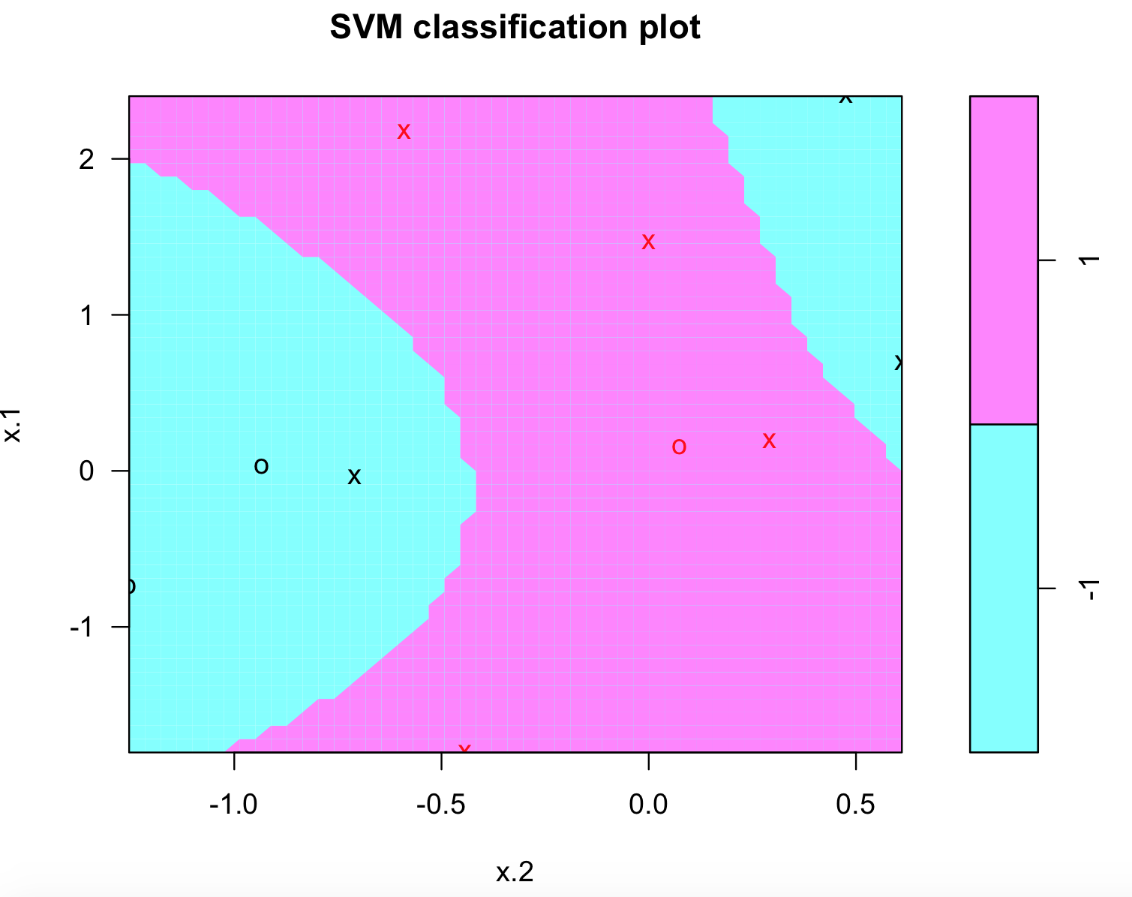

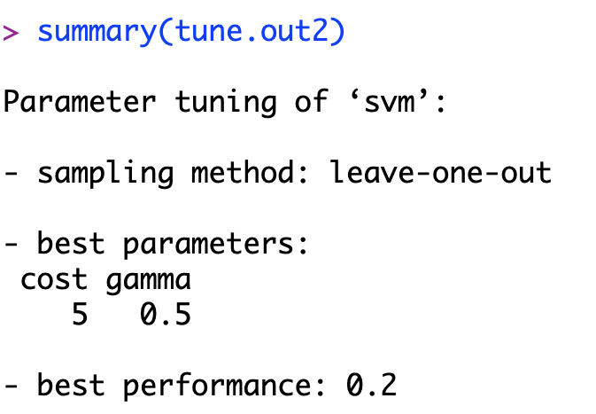

From the summary of best model after cross-validation, it is clear that cost level is 5, and gamma is 0.5. The cost level is the medium of my test cost list from 0.01 to 100. Again, it reminds me the bias-variance trade off feature of the cost level. Recall the cost level represent the tolerance of misclassification. The higher this level, the more accurate it fits to the current data set. However, when facing any new data, the resulting hyperplane might change dramatically. Conversely, a lower cost makes the hyperplane steady. If any outlier points come in, it will be misclassified, but the SVM method might just ignore this point. This will reduce variance but bias will increase. Here, a cost in the middle indicates a balanced result.

# **Apply SVM to Stock Daily Range Data**

## **2.1 Introduction to the data set**

Nordstrom(JWN)[11], a fashion retailer, sells clothes, shoes and accessories for women, men, and children in the U.S. and Canada, as one of the main competitors to Macy’s. The company operates more than retailing. It has two segments, Retail and Credit. The Retail segment offers various merchandise through different channels, including Nordstrom stores and online store at Nordstrom.com and so on. The Credit segment provides various payment products and services, like Nordstrom-branded Visa credit cards and debit cards.

Until 2018, the company operated 373 stores in 40 states. The company was founded in 1901 and is headquartered in Seattle, Washington.

I collect the daily range data, high of the day minus low of the day, for stock JWN from 09/28/2007 to 09/18/2018, around 2700 rows of data. The data set contains 7 columns, containing date, daily range on that day, lagged daily range for previous 4 days and the category assigned.



The first column JWNrange represents the daily range for that exact day in the date column. The Lag 1 column means the daily range for the previous day, so does the Lag 2~4. See the 10/2 row for Lag 1, it is the same number as the 10/1 row for JWNrange. This number 1.34 appears again in the Lag 2 for the row 10/3. For the date 10/3 in Lag2, it actually uses the daily range from 2 days ago. The Risk level is determined by whether the JWNrange exceed the medium of the whole column.

## **2.2 Cleanse of the data set**

Based on what I introduced before, the Risk level is completely decided by the JWNrange which is the actual daily range for that exact day in the date column. This two columns have strong correlation between each other (JWNrange dominates Risk!). As the purpose of the classification is using the previous daily range to predict the current daily range, the JWNrange column will be removed from my data set. Also, the Date column is not used and get removed. In addition, the nominal column Risk will be convert into numeric, “1” stands for the “HighRisk” and “-1” for the “LowRisk”.



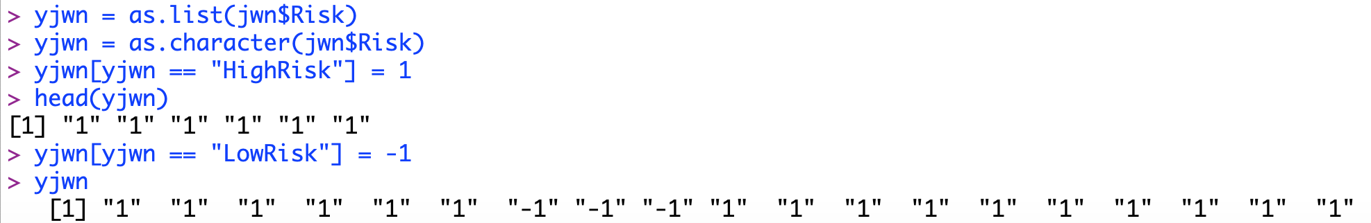

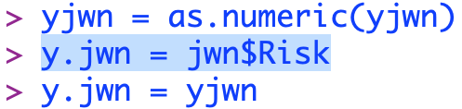

The conversion is not easy here. First, the Risk variable is a data frame rather than a list which means it cannot be directly editted. I use as.list function to convert it into a list of characters. Then, I assign 1 to HighRisk and -1 to LowRisk. Notice that everything in the list, although shown as 1 and -1, are still strings! I convert the list into numeric values by as.numeric function, named yjwn. I create a new variable y.jwn which equal to the Risk column first and then move the value of yjwn back into y.jwn. In this way, I can ensure the data structure is same so that I can use it with error message.

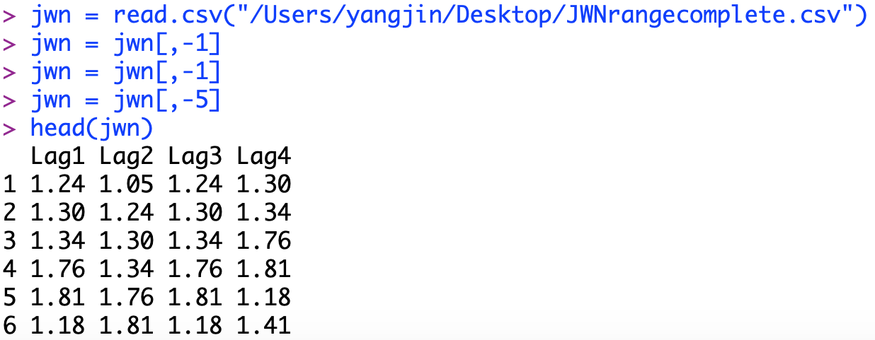

I read in the data set again to prevent any potential unknown error. I remove the first two columns by doing it one by one and then remove the Risk column. To get the full set of my range data set, I combined y.jwn as my y variable back with the cleaned jwn, named jwn.clear.



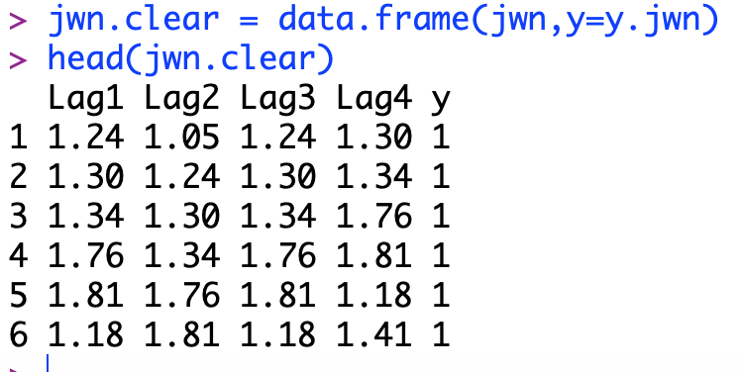

## **2.3 Apply SVM on cleaned stock range data set**

Finally, it is time to apply the SVM to see how everything works. As I have already imported the e1071 library before, I can just use the library to perform SVM on my data set. First, I will try using the linear SVM, and set the cost at 10. Here I rename the output as svm.fit to distinguish from the svmfit used before.



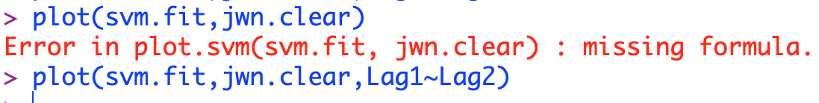

Look at this error! What’s going on? When I use my data set, my x variable have 4 columns, which means it is in 4- dimensional space! The plot function cannot plot a 4 dimensional space, so I can only display 2 out of four variables. This cause the “missing formula” error message, which essentially asks which columns you want to display.

Now, this is the idea of hyperplane. When the data set only have a 2-dimensional x variable, everyone can see the plot and a line separate them. However, a x variable with more dimensional. It comes into a higher dimensional space, and this time it is a real hyperplane.

I plot the hyperplane by only displaying the Lag1 and Lag2 as my x variable.

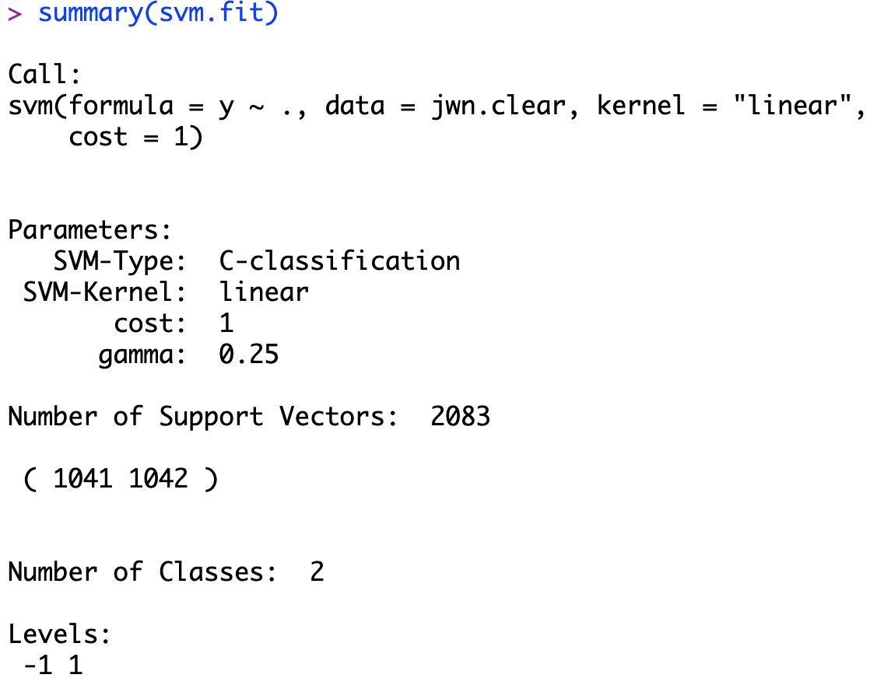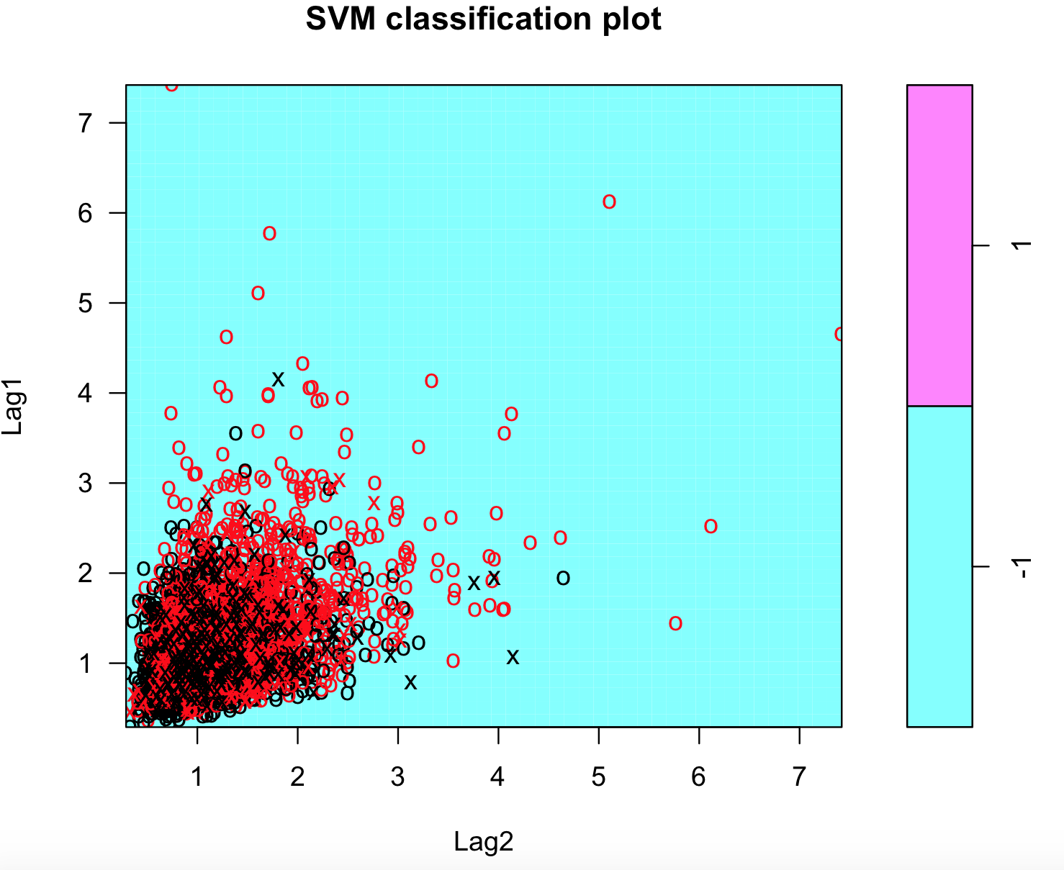

Well, the plot itself doesn’t show a lot of information. I can only see a whole blue plot with red and black points crowded together. Nothing intuitive comes out from the plot. The summary tells that 385 support vectors used. As I have around 2700 points in the data set, 2085 is not a small number. This might indicate most of the points are not significantly belong to one category.

The only way to see the performance of my SVM method is to use the predict function and see the correct rate.

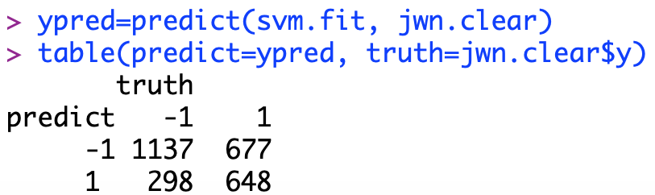

The correct rate is (1137+648)/(1137+648+677+298) = 64.67%. The result doesn’t improve so much comparing to 64% in K-NN and 60% in logistic regression. It seems like the limitation is around this value. I still want to try the cross-validation for the SVM to see any improvement could be made.

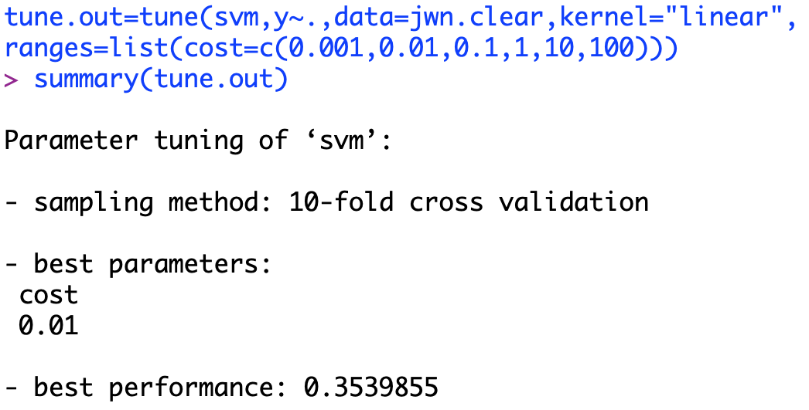

The code is short but the computing time is massive. The cross-validation choose the cost level at 0.01, the second smallest cost level.

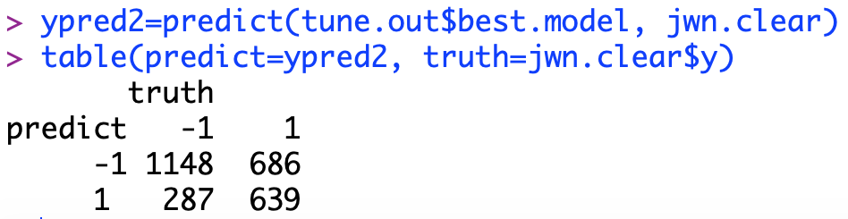

Then I use the best sub-model to predict the categories. Now, the correct rate is (1148+639)/(1148+639+686+287) = 64.74%. Fine, at least, the best sub-model after cross-validation improves the correct rate 0.07%.

## **2.4 Apply non-linear SVM**

For knn, logistic regression and linear SVM, they all have similar feature – linear. In general, using a non-linear method will somehow increase the correct rate of classification. The curse of dimensionality tells me this improvement might result just from the nature feature of high dimensional space.

To use a radial kernel SVM method, simply change the kernel = “radial”. Also, a “gamma” parameter need to be specified in radial SVM. Gamma is some kind of shape controlling parameter to modify the shape of hyperplane to find a better fit. I will first try the radial kernel to produce a non-linear boundary.

The SVM result is renamed as svm.nl, the cost level is set as 0.01, which is best selection in linear SVM.

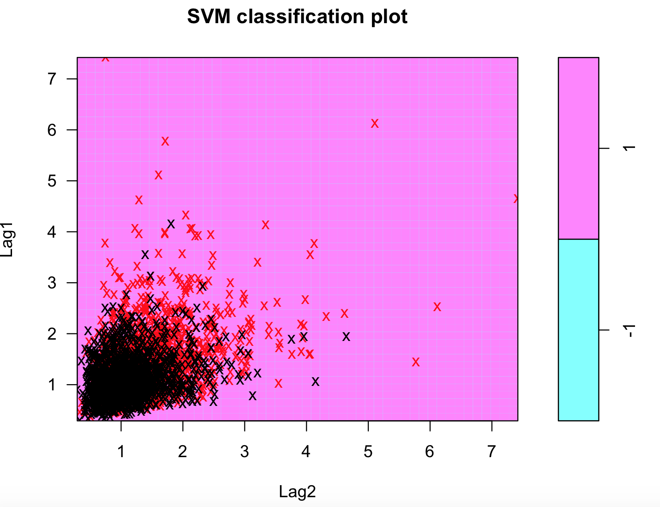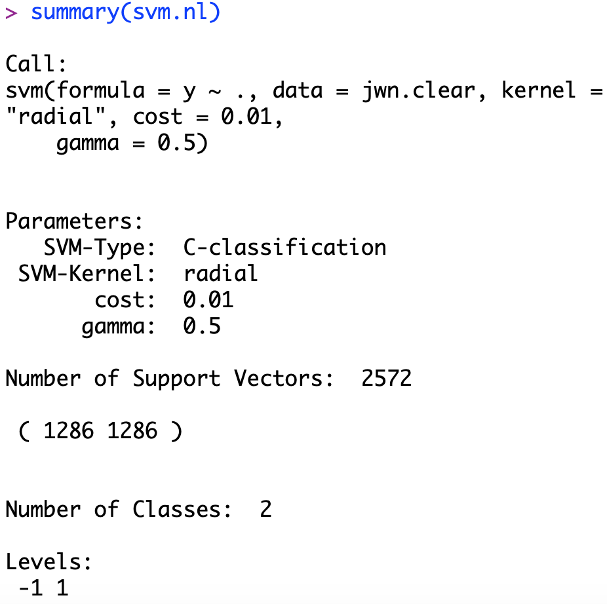

Again, the plot becomes all purple rather than blue. I have no idea what’s happening to it. The summary report tells me it utilized 2572 points, which is more than the linear SVM. This might indicate the non-linear classification works poorer than linear. See the correct rate:

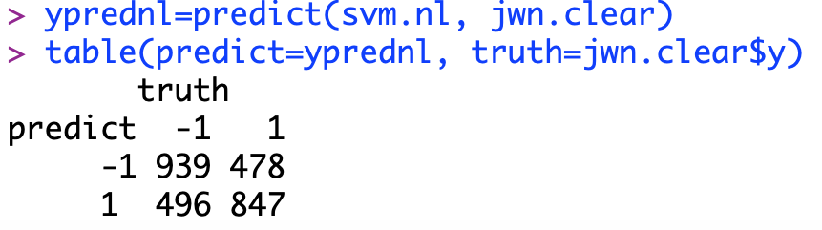

The correct rate is (939+847)/(939+847+478+496) = 64.71%. The result has no improvement. Even increasing dimensionality cannot improve the classification. This makes me think of the idea of non-separate data set. The data set is not always separable; like stock range data, it has strong relationship between each day. No matter which method I choose, the basic non-separable feature of it will not change. However, let me continue to try cross-validation to search for a better pair of cost and gamma, which might increase the correct rate of classification.

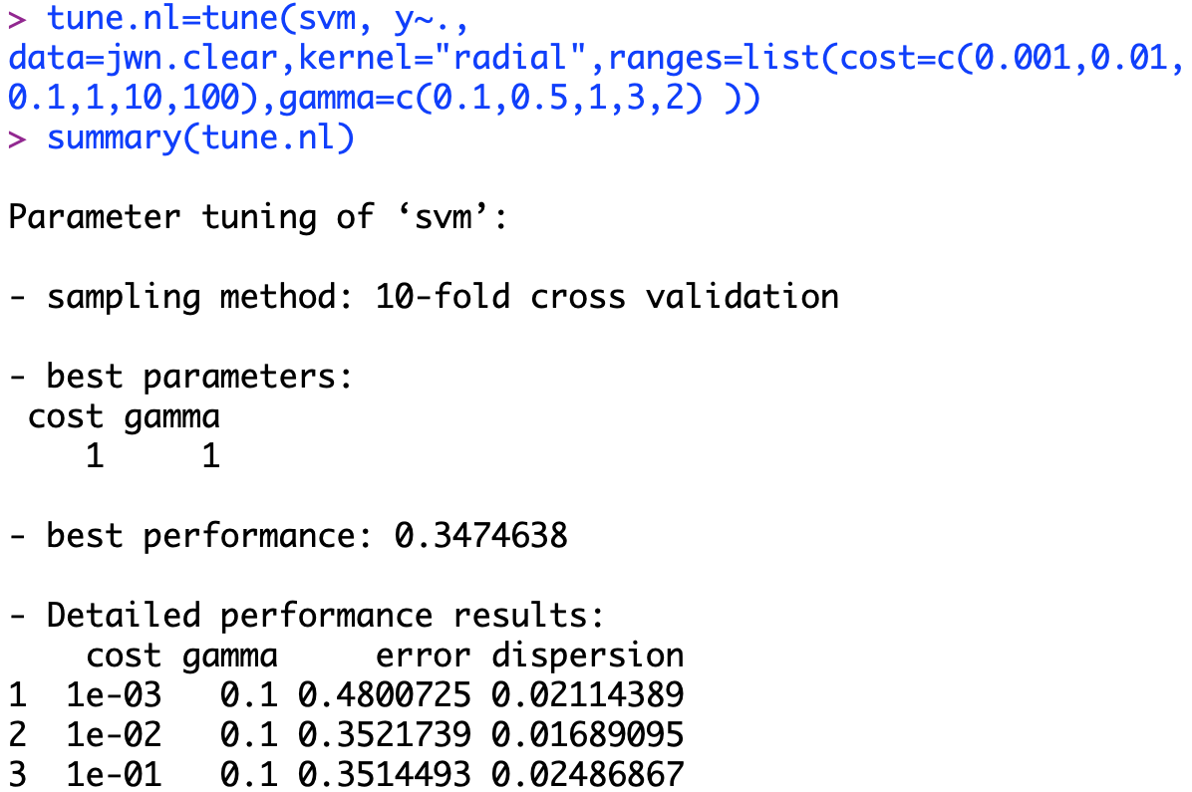

Computing time of cross-validation is always long. The result shows the best sub-model chooses the cost and gamma level both at 1. Notice the “10-fold cross validation” is different from the “leave one out” cross validation method in the previous section. This method might increase speed of the cross-validation to make it not too long. Now, let’s see the change of correct rate.

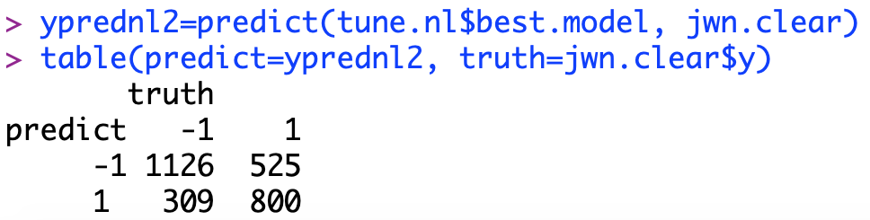

The correct rate is (1126+800)/(309+525+1126+800) = 69.7%. Nice! Finally, some progress has been made! The non-linear SVM method improve 5% more than linear SVM, KNN and logistic regression.

## **2.5 Apply SVM to reduced dimensional range data**

When 4 dimensional x variable leads to a non-observable classification space, I decide to reduce the dimension back to 2 and plot some intuitive hyperplane as the end for the range data.

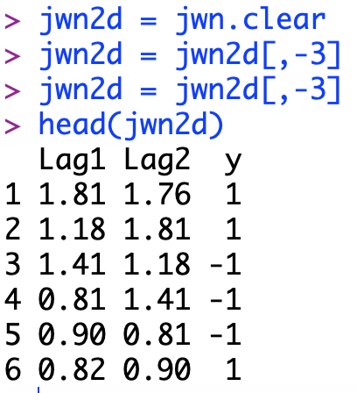

For the data set, I name it as jwn2d and remove Lag 3&4 daily range out of it. Now inside my data set is only Lag1, Lag2 and y.

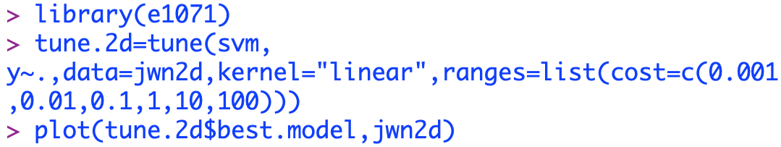Then I first apply the linear SVM method to it just as I did before. Because the process are same, I directly use the tune() function on my 2 dimensional data set to get the best method after cross validation.

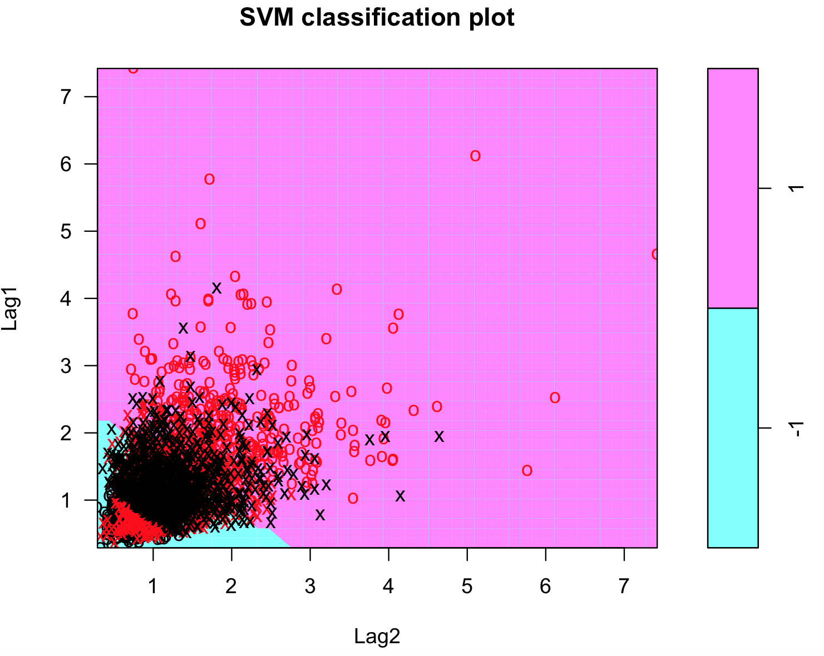By reducing the dimensionality, the graph shows two different categories in one plot. I can see the blue part centered in the left bottom corner. It could possibility indicates some pattern of risk level changed by date. If daily range of the previous days, lag 1 and 2 days, is low or stable, the daily range for the current date will likely in a similar range. In other words, if daily range is low risk in recent days, it will remain low risk in short future.

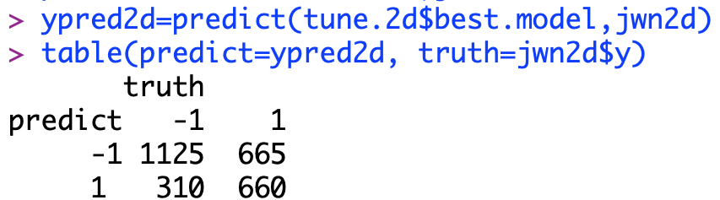

Then I compute the correct rate, as (1125+660)/(1125+660+665+310) = 64.67%. This fairly close to other linear classification methods. Comparing to use 4 dimensional x variable I did before (64.71% correct rate), it is clear than increasing dimensionality doesn’t necessarily improve the performance. Nevertheless, the graph here is more intuitive and useful on decision making. If a new data point plot in the blue area, I could consider as a blue category, as -1, is low risk.

Now let me try non-linear classification and plot the result.

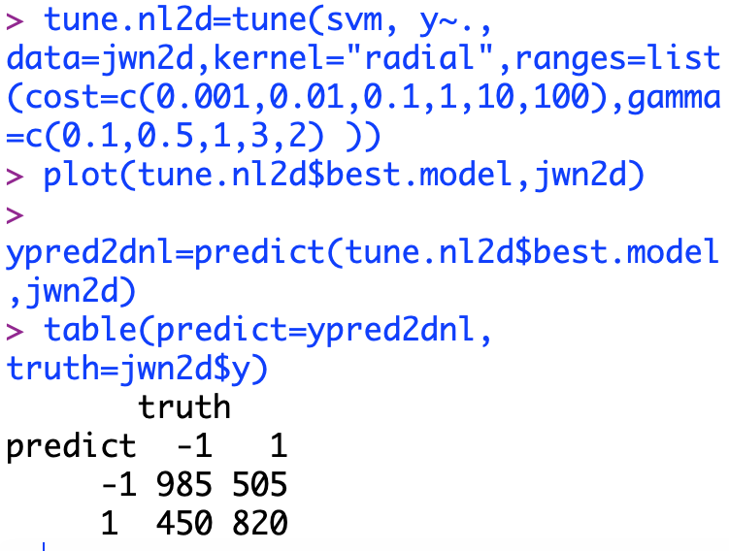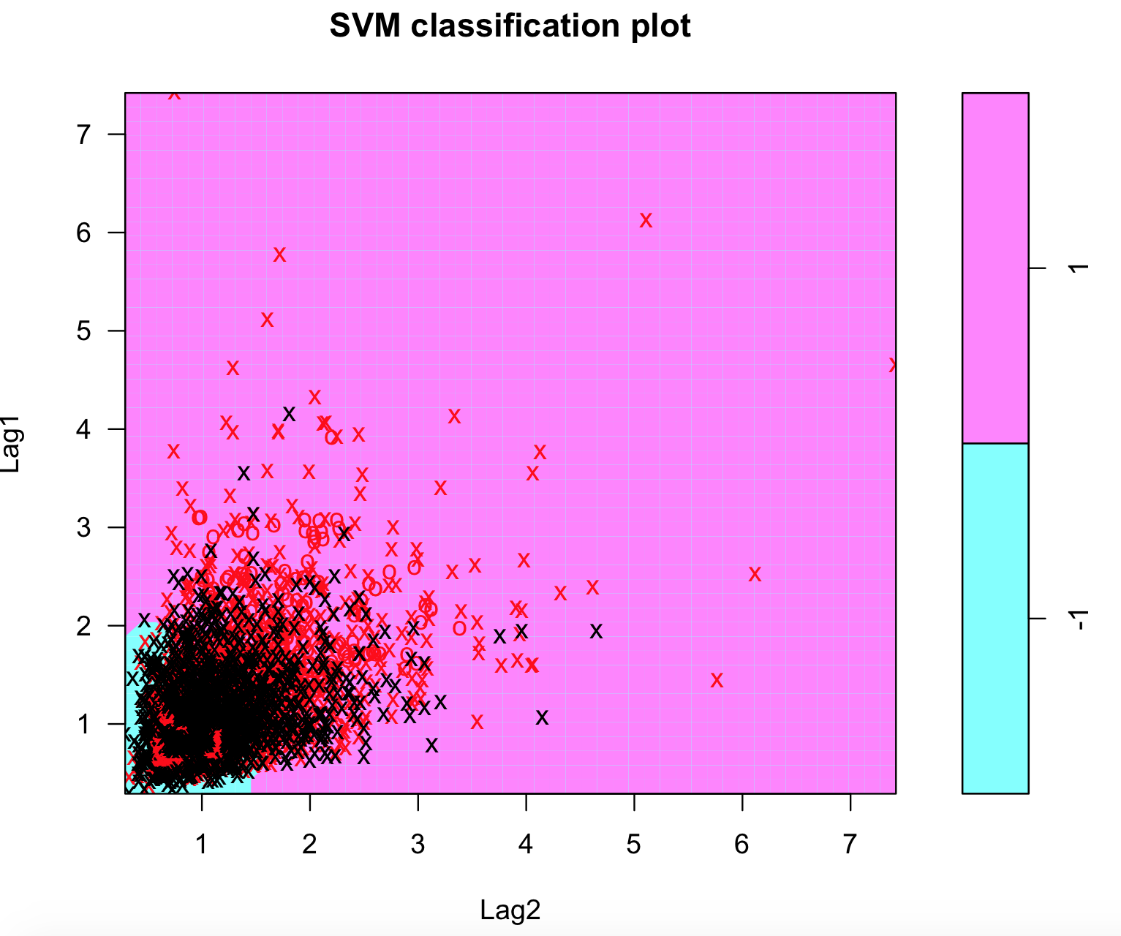

The correct rate is (985+820)/(985+820+450+505) = 65.39%. The best model selects a cost 0.1 and gamma as 3. The graph here is intuitive and I can see the blue area becomes much smaller and has an irregular boundary. It becomes easier to classify as purple, which is high risk. It might indicate the movement on the risk level is not so stable. Somehow it balances the correct between 1 (high risk) and -1(low risk). In linear situation, the correct rate of predict -1(low risk) and actually is -1 is higher than the reverse (1125/660). Here, it is 985 to 820, the correct rate for predicting 1 correctly and -1 correctly are close to each other.

# **Apply SVM to Original Data Set**

## **3.1 Introduction to the data set**

Times Square Property Data (Commercial and Retail properties).

I retrieve this data from NYC Open Data[12]. In general, this data set contains a detailed information for the main commercial and retail use properties in time square. The original data set contains more than 49 columns and 163 rows. It is not a very big data set but fairly enough for me to apply SVM on it. In addition, a smaller data set will save massive computing time.

I am interested in using several numeric attributes to provide whether the property is used a retail building or an office building.

Inside the data set, many columns are either nominal or almost empty. They are not used and removed. Following is a list of meaning for every column’s name. The “PropertyType” will be my y variable as I want to predict the usage of a certain building.

*PropertyType*: the usage of the building, either Retail or Office

*Number of Stories*: the total number of levels in a building

*Land Area*: the land area a building occupied

*Rentable Building Area*: total rentable area in a building

*Typical Floor Size*: the size for each floor



The PropertyType is my y variables, it only contains Retail or Office, of which a building belongs to what I will predict. Number of stories simply means how many levels of floors are there inside a building. Land Area uses acre as its unit and stands for the land area it used. Rentable building area tells how many areas inside the building can be rented. Typical floor size represents average size for each floor in the building. With all these numeric data, it is enough for people to image how the building looks like, a high building with ten large floors. Also, these data might reveal the usage of the building.

## **3.2 Cleanse of the data set**

As the purpose of the classification is using some building attributes to predict the usage of the building, the Property column will be convert to y variable and then removed from my data set. Also, there are several empty rows inside and I manually delete all these rows thank to the limited size of my data set. The Property column will be convert into numeric, “1” stands for the “Retail” and “-1” for the “Office”.

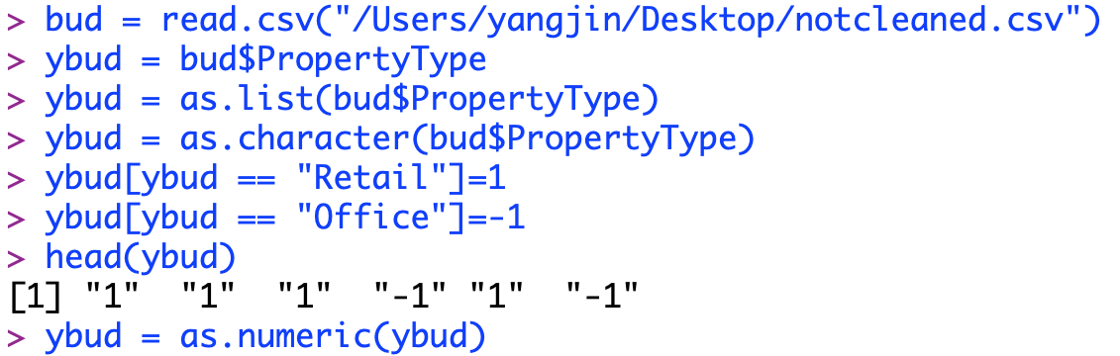

The conversion here is similar to what I did for my daily range data. First, the PropertyType variable is a data frame and then converted into a list of characters. Then, I assign 1 to “Retail” and -1 to “Office”. In addition, they need to be converted back into numeric values by as.numeric function, named ybud. Then, I read in the data set again to prevent any potential unknown error. I removed the PropertyType column as I already have my y variable. To get the full set of my range data set, I combined ybudas as my y variable back with the cleaned bud data, named bud.clear.



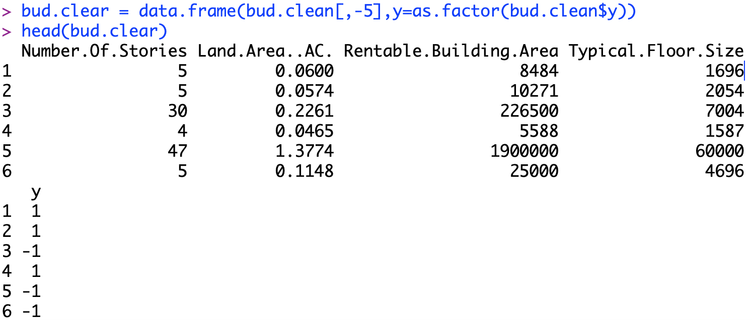

## **3.3 Apply SVM on cleaned property data**

Now let me apply the SVM to see how everything works. I imported the e1071 library before, and try using the linear SVM, and set the cost at 5. Here I rename the output as svm.bud to distinguish from the svm.fit used before.



Notice when I use my data set, my x variable have 4 columns, or I have 4 x variables, which means it is in 4-dimensional space. A 4-dimensional space cannot be plotted, so I can only plot 2 variables. Recall the idea of hyperplane. When the data set only have a 2-dimensional x variable, the plot of the classification space and hyperplane is intuitive. However, a x variable with more dimensional becomes a higher dimensional space, and a real hyperplane.

I plot the hyperplane by only displaying the “Rentable Building Area” and “Typical Floor Size” as my x variable.

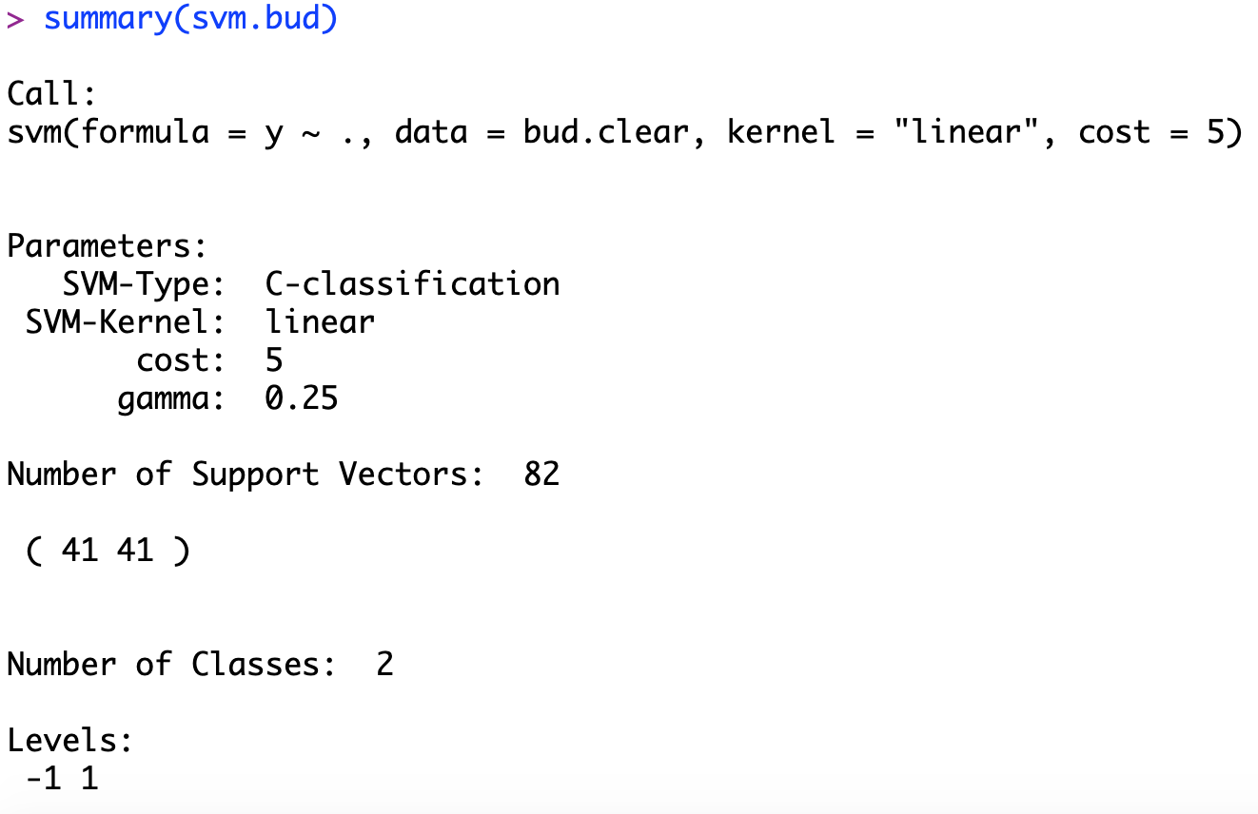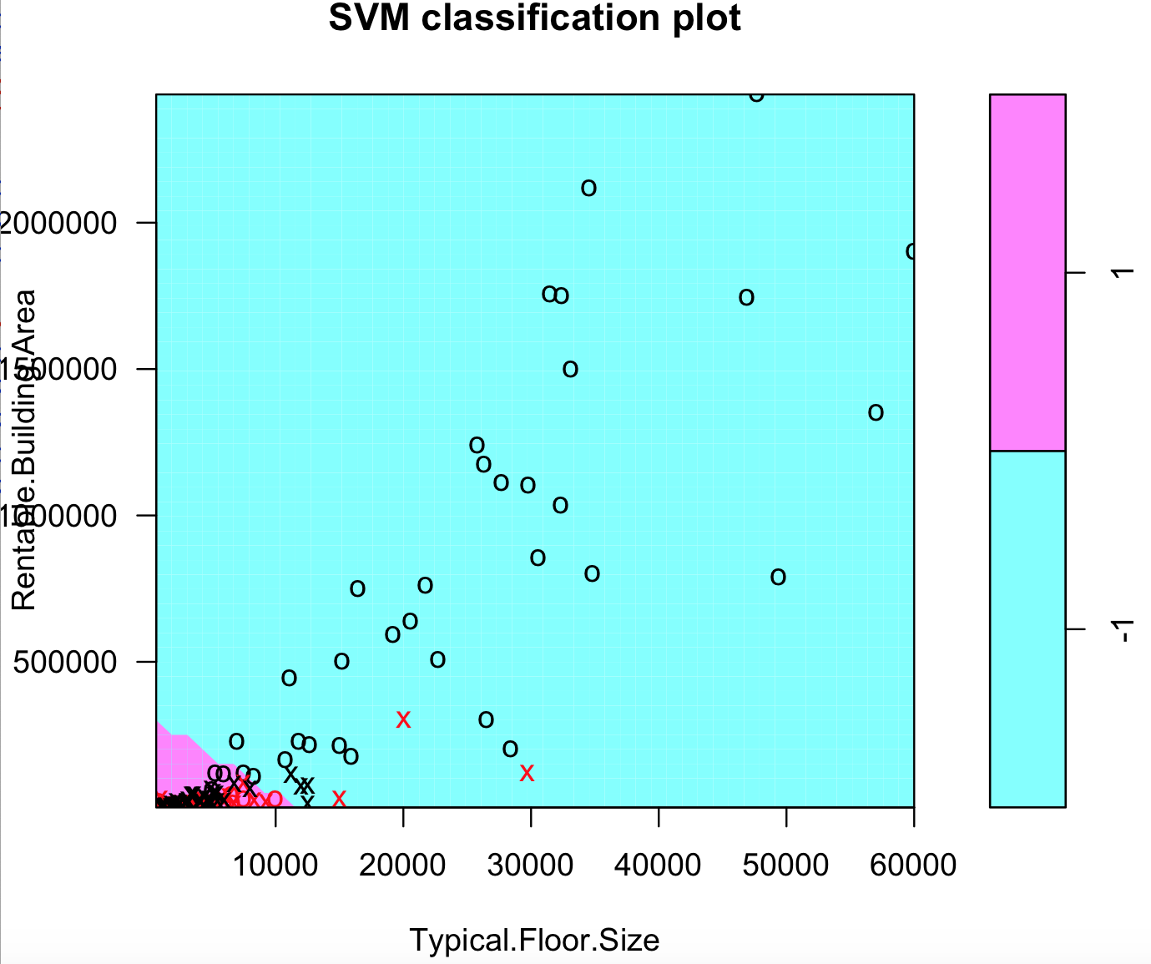

The plot looks better than the stock daily range data. I can see a whole blue plot with some area of purple centered at left bottom corner. Something intuitive comes out from the plot. The summary tells me that 82 support vectors used. As I have around 153 points in the data set, 82 is about half of all the points. I can visualize many “o” points, which means they significantly belong to one category.

I can measure performance of my SVM method by using the predict function and see the correct rate.

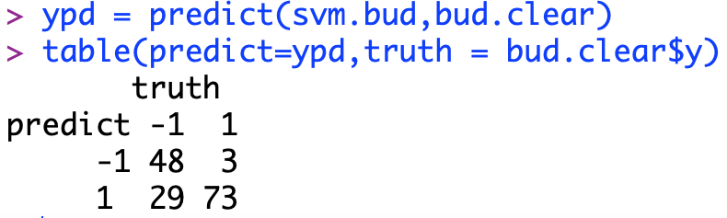

The correct rate is (48+73)/(48+73+3+29) = 79.08%. The result looks very good already, and improve a little bit comparing to 70% in logistic regression. This means the choice of x variables has described the attributes of buildings quite correctly, which does have correlation to how people want to use the buildings. I then try the cross-validation for the SVM to see any improvement could be made.

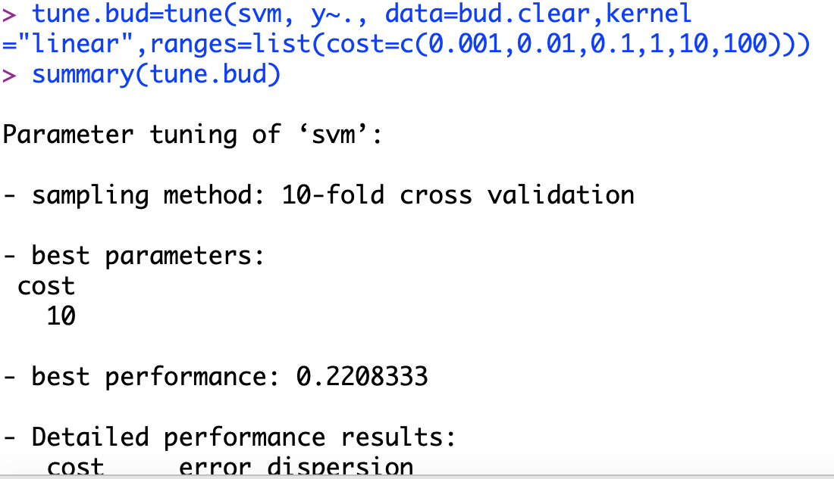

Now the data set is shorter, so saved a lot computing time. The cross-validation choose the cost level at 10, the second largest cost level.

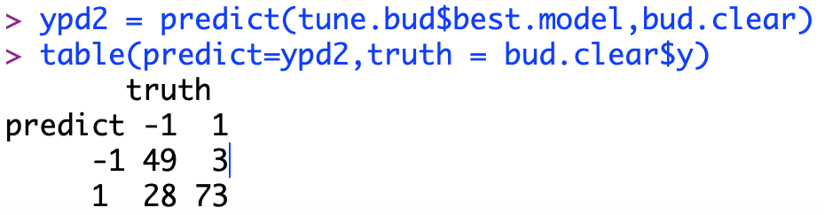

Then I use the best sub-model to predict the categories. The correct rate is (49+73)/(49+73+28+3) = 79.74%. Compare to a randomly selected cost level, the best sub-model after cross-validation improves the correct rate 0.7%.

## **3.4 Apply non-linear SVM**

In general, I hope using a non-linear method will increase the correct rate of classification more than my daily range data. I am going to use a radial kernel SVM method, by simply change the kernel = “radial”. Also, a “gamma” parameter need to be specified in radial SVM. Gamma is some kind of shape controlling parameter to modify the shape of hyperplane to find a better fit.

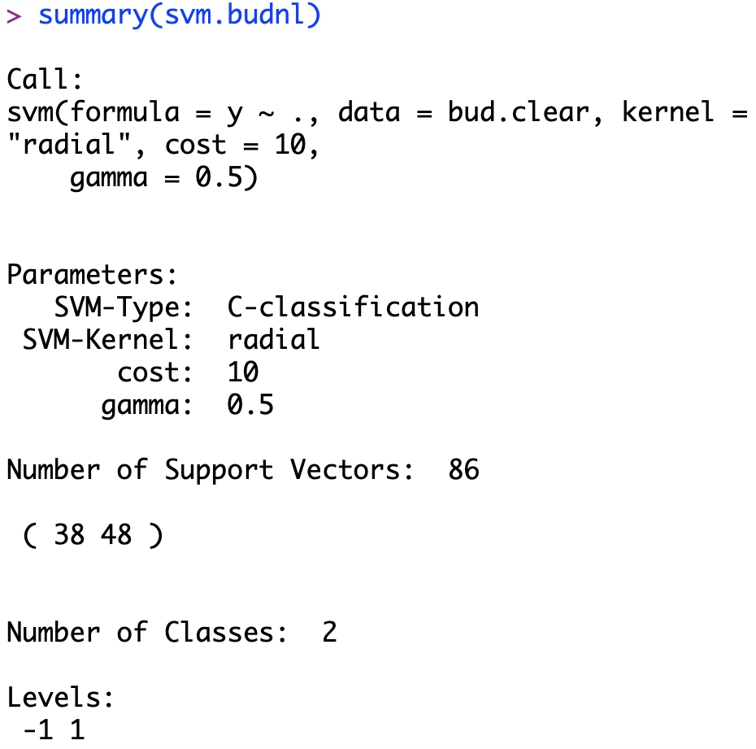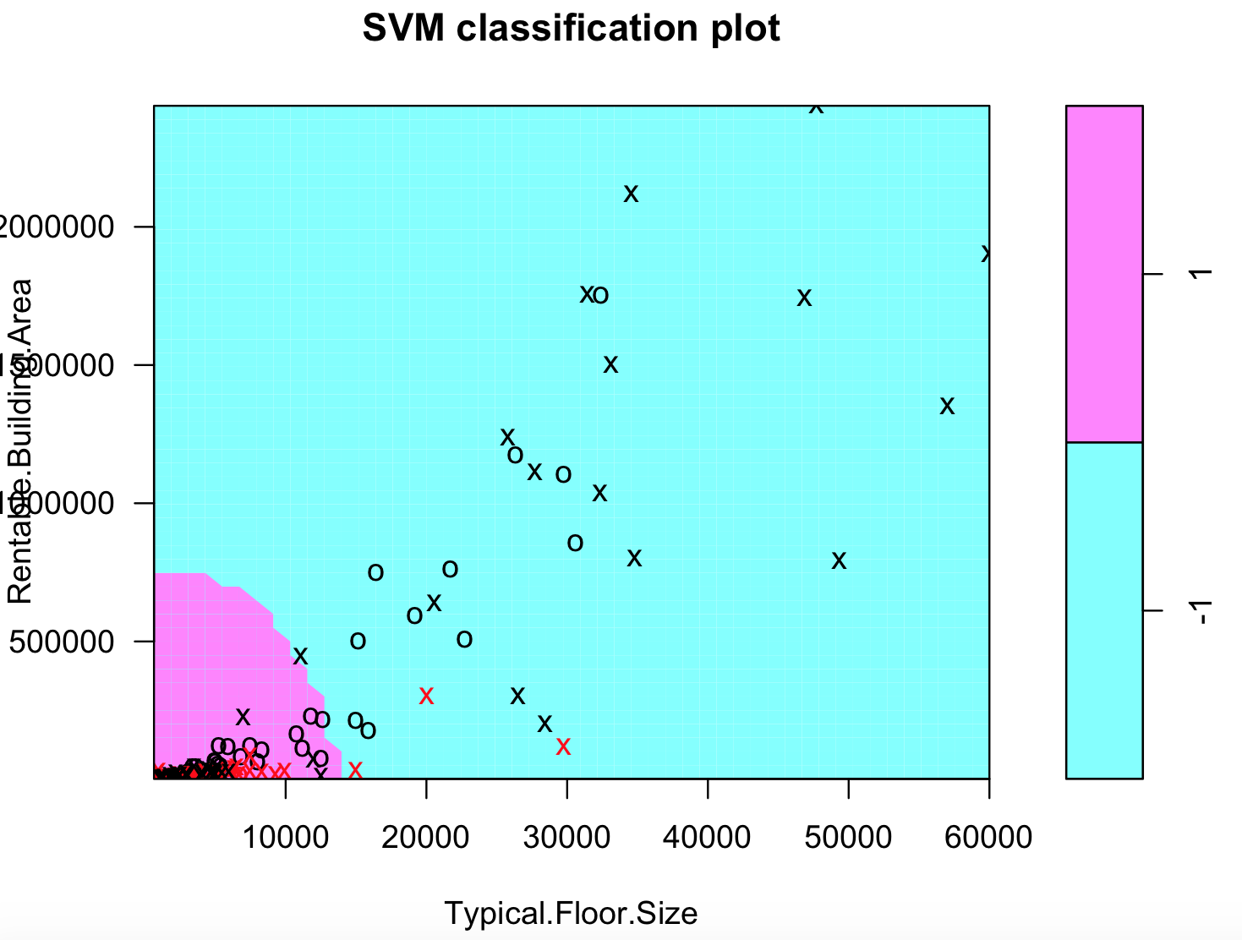The SVM result is renamed as svm.budnl (short for svm.buliding.non-linear), the cost level is set as 10, which is best selection in linear SVM. 

Oh, it is a quite nice plot has an obverse irregular boundary classification area in the left bottom. Finally, I am so glad the SVM plot can give something very intuitive and accord with the theoretical features I went through before. The summary report tells me it utilized 86 points, which is more than the linear SVM. See the correct rate:

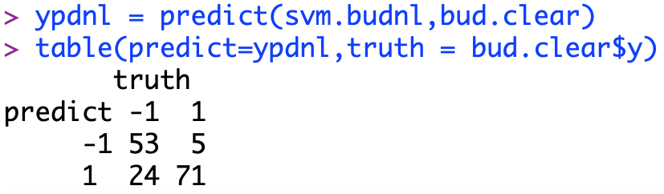

The correct rate is (53+71)/(53+71+5+24) = 81%. The improvement is significant. Increasing dimensionality improve the classification correct rate over 80%. Imaging if stock data can be predicted in this correct rate, I would be rich in seconds. The data set is partially separable. All my x variables somehow reflect the aspects people will consider when decide the usage of the buildings. Let me continue to try cross-validation to search for a better pair of cost and gamma, to see the highest correct rate I can get.

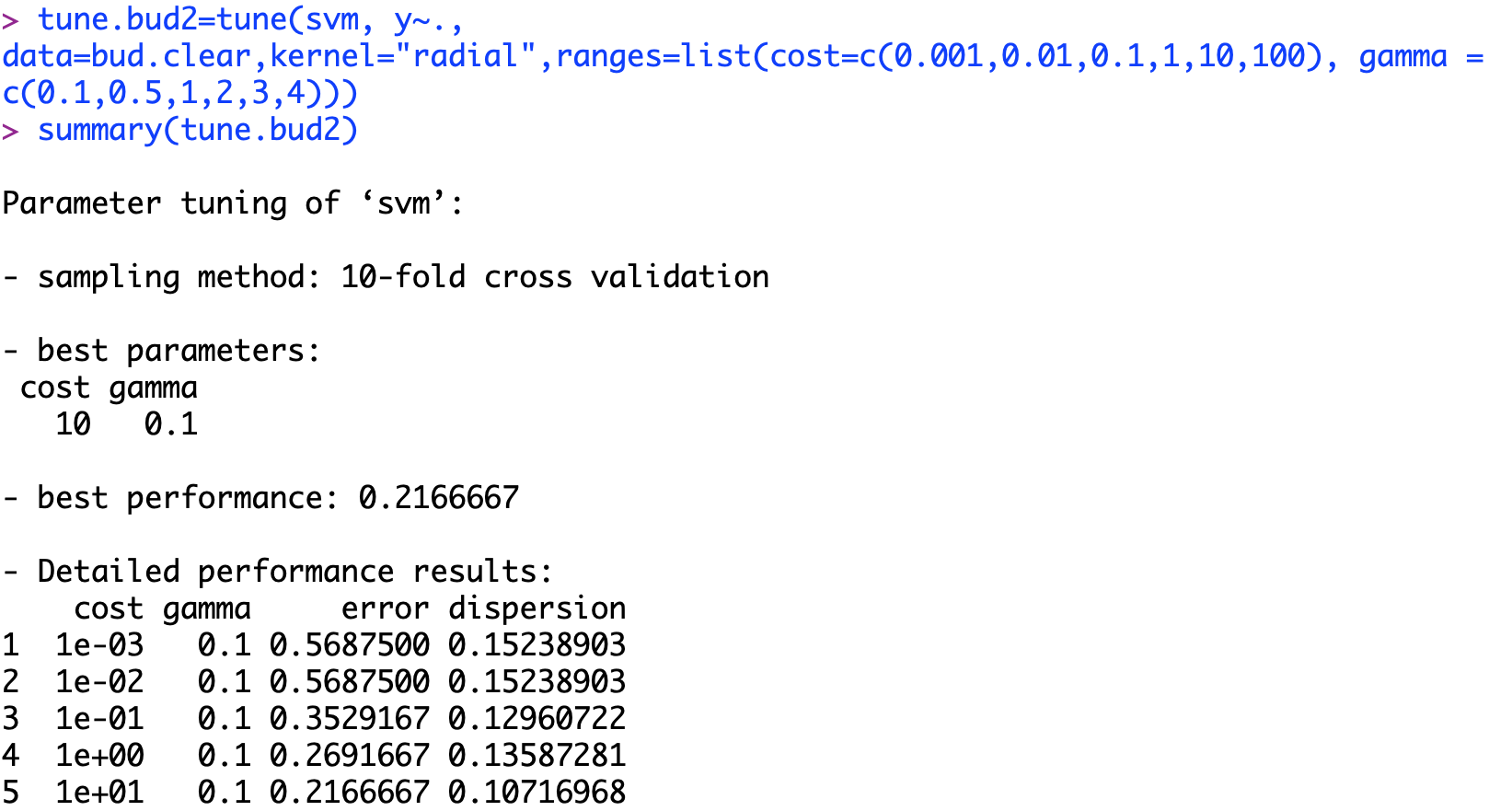

The result shows the best sub-model chooses the cost level at 10 and gamma level at 0.1. The cost level is fairly high, which means high tolerance for misclassification. This might indicate there are a part of data doesn’t share a similar with other points in both points. One possible reason for this could be location. For the buildings in the popular areas, no matter how them look like, people might always want to retail them for higher profit. Now, let’s see the change of correct rate.

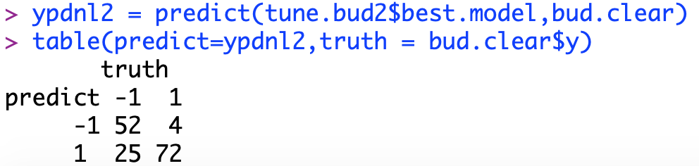

The correct rate is (52+72)/(52+72+25+4) = 81%. It seems I select the best level at the first trial. Anyway, the 81% correct rate is very good for my classification. Remember I want to use the architectural attributes to predict how the buildings are used. A 81% correct classification means the architectural structure is one of the main consideration when people decide how to profit from their properties.

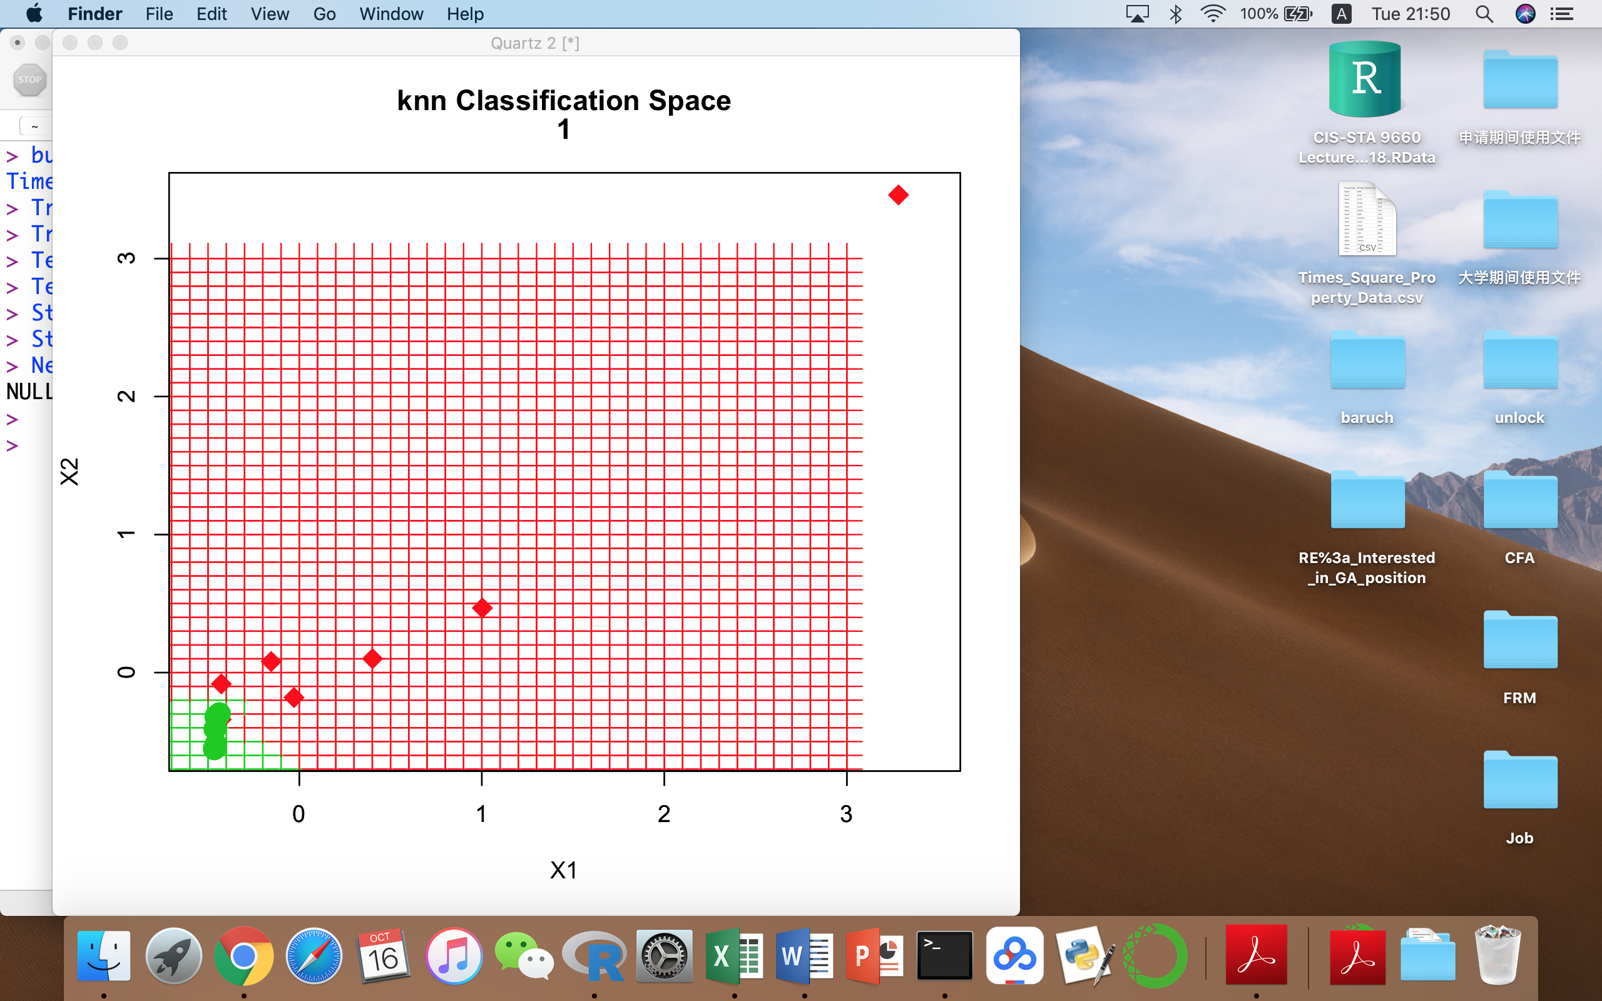

A subset of this data set has been used for knn classification. The classification space is presented in the left. By selecting a k=1, its correct rate is 67%. Comparing to the knn method, the linear SVM and non-linear SVM method perform a lot better. However, 67% by just using simple knn could imply the data set itself is separable.

Anyway, I can say that knowing “Number of Stories”, “Land Area”, “Rentable Building Area” and “Typical Floor Size”, using non-linear SVM can predict the usage of a property in time square.

# **Reference List**

1. Page 337~366, James, Gareth, et al. *An Introduction to Statistical Learning with Applications in R*. Springer, 2017.
2. “JWN: Summary for Nordstrom, Inc.” *Yahoo! Finance*, Yahoo!, 16 Dec. 2018, http://finance.yahoo.com/quote/JWN?p=JWN&.tsrc=fin-srch.
3. Times Square Property Data Commercial and Retail. *NYC Open Data*, http://data.cityofnewyork.us/City-Government/Times-Square-Property-Data-Commercial-and-Retail-p/j86k-5i43.
4. “Linear Regression Example.” *1.4. Support Vector Machines - Scikit-Learn 0.19.2 Documentation*, scikit-learn.org/stable/auto_examples/linear_model/plot_ols.html.
5. “Support Vector Machines in R.” *DataCamp Community*, http://www.datacamp.com/community/tutorials/support-vector-machines-r.
6. “Support Vector Machine.” *Hierarchical Cluster Analysis · UC Business Analytics R Programming Guide*, http://uc-r.github.io/svm.
7. “e1071.” *Function | R Documentation*, http://www.rdocumentation.org/packages/e1071/versions/1.7-0/topics/svm.

1. Graph used in cover page is retrieved from https://e-discoveryteam.com/tag/support-vector-machines/
2. P352, James, Gareth, et al. *An Introduction to Statistical Learning with Applications in R*. Springer, 2017.
3. P355, James, Gareth, et al. *An Introduction to Statistical Learning with Applications in R*. Springer, 2017.
4. The Graph below is drawn manually only for explanation purpose, not real SVM result.
5. P361, James, Gareth, et al. *An Introduction to Statistical Learning with Applications in R*. Springer, 2017.
6. The Graph below is drawn manually only for explanation purpose, not real SVM result.
7. P366, James, Gareth, et al. *An Introduction to Statistical Learning with Applications in R*. Springer, 2017.
8. P377, James, Gareth, et al. *An Introduction to Statistical Learning with Applications in R*. Springer, 2017.
9. P367, James, Gareth, et al. *An Introduction to Statistical Learning with Applications in R*. Springer, 2017.
10. P378, James, Gareth, et al. *An Introduction to Statistical Learning with Applications in R*. Springer, 2017.
11. https://finance.yahoo.com/quote/JWN?p=JWN&.tsrc=fin-srch
12. https://data.cityofnewyork.us/City-Government/Times-Square-Property-Data-Commercial-and-Retail-p/j86k-5i43